Projet ASP2021

DI FALCO SIMON & HUYGEBAERT Gabriel



# Énoncé

Le travail s’inspire de l’actualité. Votre client souhaite que vous réalisiez une plateforme web pour les restaurateurs souhaitant mettre en place un système de plats à emporter (take-away).

L’objectif de l’application est d’automatiser un maximum de tâches :

1. La plateforme est destinée à plusieurs restaurateurs.
2. Un restaurateur intéressé pourra inscrire son restaurant sur la plateforme.
3. Un restaurateur proposera des menus (par ex. : entrée-plat-dessert, 2 entrées-plat-dessert, …) et des plats à la carte.
4. Un plat à la carte a un prix. Un menu a un prix (pas une addition des prix des plats).
5. Chaque jour, le restaurateur propose deux services (service du midi et service du soir).
6. Un client passera sa commande pour un des services du jour (il ne peut commander pour un autre jour) au plus tard 2 heures avant le service.
7. Un client qui habite à proximité du restaurant pourra demander une livraison à domicile, moyennant frais supplémentaire.
8. Un client qui n’habite pas à proximité devra venir chercher ses plats sur place.
9. Pour passer la commande, le client doit créer un compte dans lequel il fournira toutes les informations nécessaires.
10. Seul un utilisateur authentifié peut passer une commande.
11. Un visiteur de la plateforme peut consulter les menus sans s’authentifier.
12. Un restaurateur devra s’authentifier pour ajouter son restaurant, gérer ses menus et gérer ses commandes.

Table des matières

Énoncé 1

Façon d’utiliser le programme 4

SQL server Management Studio 4

Dans le programme 4

Compte client 7

Compte restaurateur 7

Base de données 7

Schéma conceptuel 7

Procès-Verbaux 8

Réunion 1 8

Réunion 2 9

Réunion 3 10

Réunion 4 11

Réunion 5 12

Réunion 6 13

Réunion 7 13

Réunion 8 13

Réunions >8,9… 13

Analyse 14

Use case diagram 14

Préambule 14

JET 1 14

Jet 2 15

Jet 3 16

Jet 4 17

Jet final 18

Scénarios 19

Class diagram 52

Préambule 52

JET 1 présenté ( 02-04) 52

Jet 2 53

Jet 3 54

Jet 4 55

Jet 5 56

Jet final 57

Sequence diagram 58

Préambule 58

Diagrammes de séquence Jet 1 58

Jet 2 67

Jet 3 79

Jet final 83

Conclusion 97

# Façon d’utiliser le programme

## SQL server Management Studio

Créer une base de données vide locale et implémenter les scripts sur SQL server Management Studio grâce aux fichiers .sql fournis avec le projet. Les requêtes seront automatiquement traitées. D’abord le script des tables et puis quelques insertions pour permettre de tester les fonctionnalités de l’application.

## Dans le programme

Pour avoir accès à la base de données locale, il faut faire le lien avec celle-ci et le programme mais aussi installer un package (cfr ci-dessous).

D’abord il faudra créer la DB :

1) Dans Microsoft SQL Server Management : CREATE DATABASE ASP_Project_02

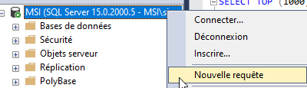

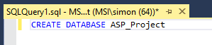

2) Attention : exécuter les fichiers sql présent dans le dossier fourni ‘table’ dans ‘db’ IMPERATIVEMENT dans l'ordre ci-dessous

-) customers.sql

-) restorers.sql

-) restaurants.sql

-) opinions.sql

-) schedules.sql

-) dishes.sql

-) menus.sql

-) menuDetails.sql

-) orders.sql

-) ordersDishDetails.sql

-) ordersMenuDetails.sql

3) Cliquer sur « insertion_db_final.sql » après avoir cliqué sur « nouvelle requête » dans SQL Management :

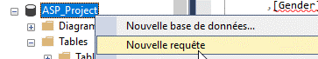

Cliquez sur le fichier :



D’abord s’assurer que l’explorateur d’objets SQL server est bien installé sur visual studio. La base de données locale « ASP_Project » créée apparaîtra ici.

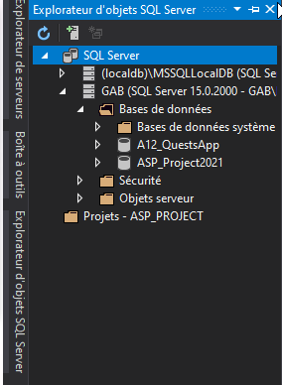  
Ensuite, clic droit sur la racine du projet pour pouvoir installer des **packages NuGet**.

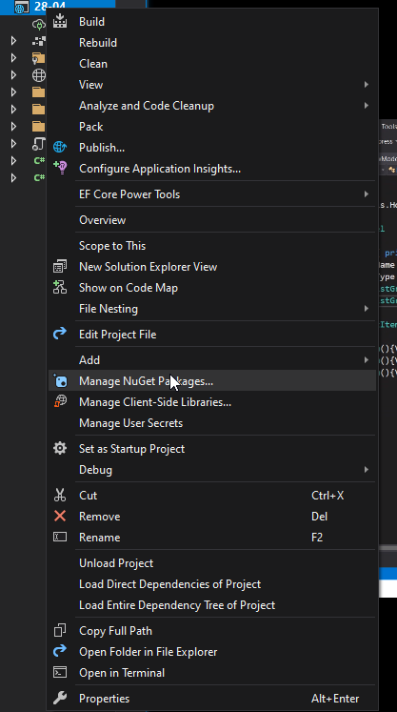

Installer ce package

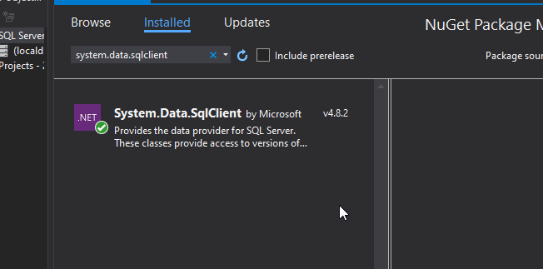

Modifier la **connection string** en fonction de votre propre chemin vers la bdd locale. Voici comment accéder à votre connection string :

1. Double clic sur votre DB dans Visual studio :

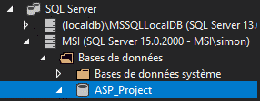

1. Une zone de la page visual studio nommée « Propriétés » apparaît, chercher « Chaine de connexion »

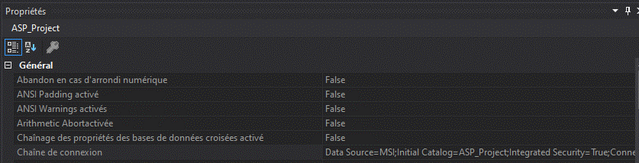

1. Faire un copier de cette chaîne
2. Se rendre dans le fichier suivant :



1. Remplacer la chaine vide de connexion(« ») dans « ConnectionStrings » correspondant à « professeurs »



1. Se rendre dans startup.cs et remplacer (sera fait pour vous) la connection string à récupérer par « professeurs ».

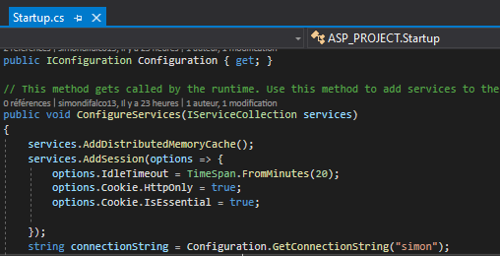

Lancer l’application. (ATTENTION : ne pas oublier de lancer l’application de la DB) :

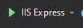  
Si vous souhaitez tester la création de compte, s’inscrire.

Si pas, vous connecter avec un client et puis le restaurateur pour procéder aux tests.

### Compte client

Login : arnaud.verbeer@gmail.com  
MDP : Pass1234

### Compte restaurateur

Login : roland.vagand@gmail.com  
MDP : Pass1234

Attention à la majuscule sur le password.

# Base de données

## Schéma conceptuel

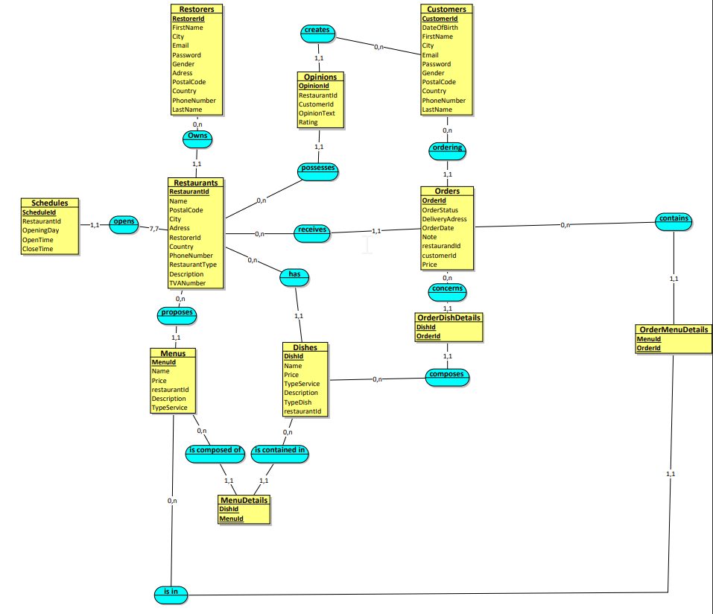

# Analyse

## Use case diagram

### Préambule

Étant la première étape d’une analyse, le diagramme des cas d’utilisation est utile pour permettre de bien distinguer les limites du programme (acteurs, systèmes et utilisations) et les présenter à un client. Les scénarios qui sont associés à chaque use case décrivent les cas d’utilisation de manière générale.ss

### JET 1

### Jet 2

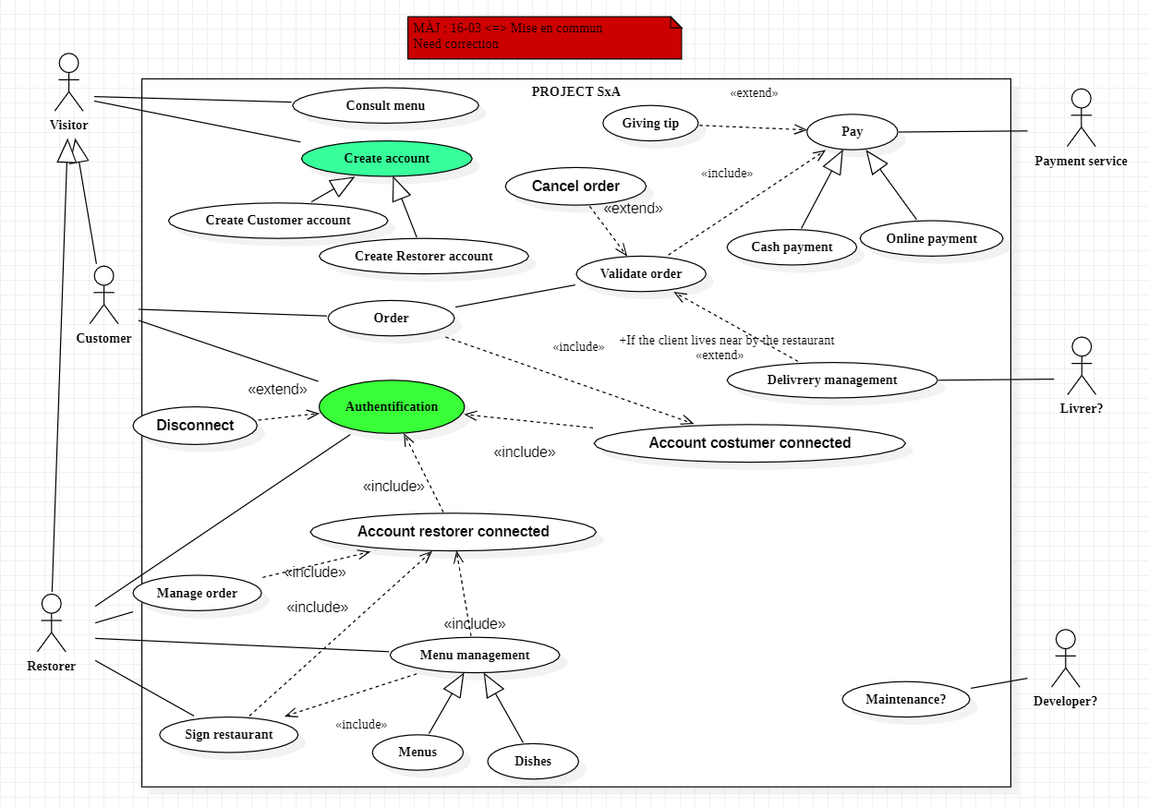

### Jet 3

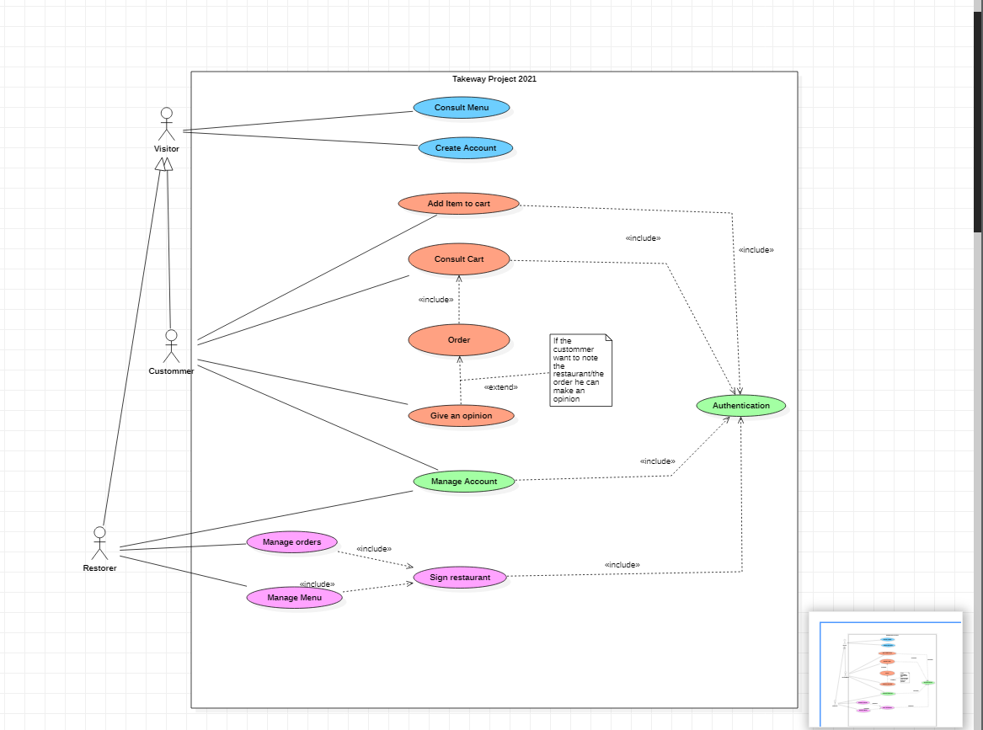

### Jet 4

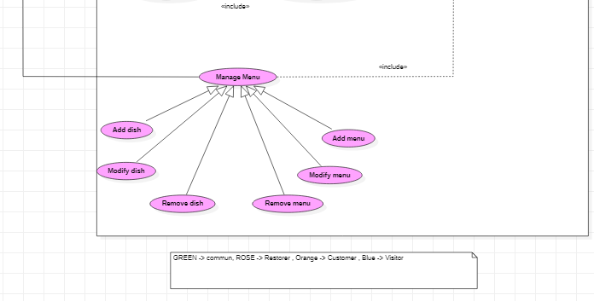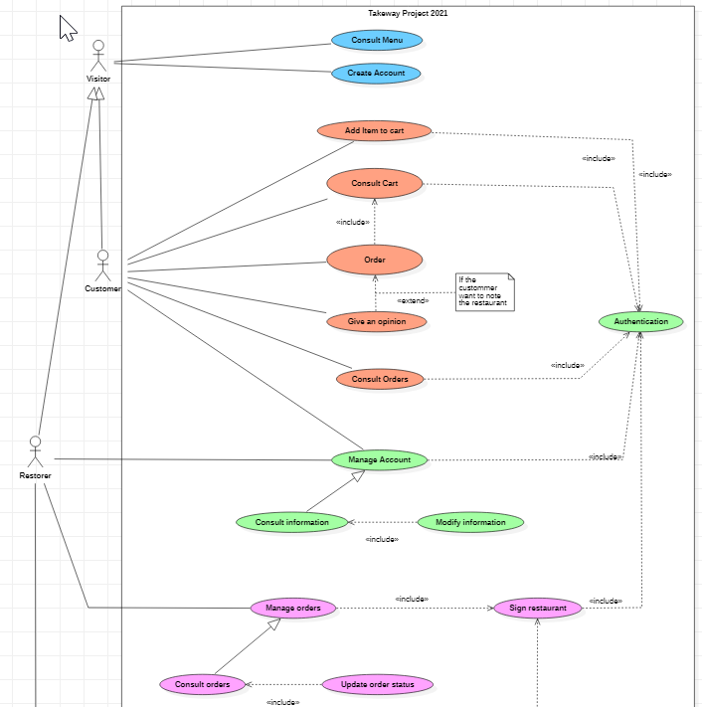

### Jet final

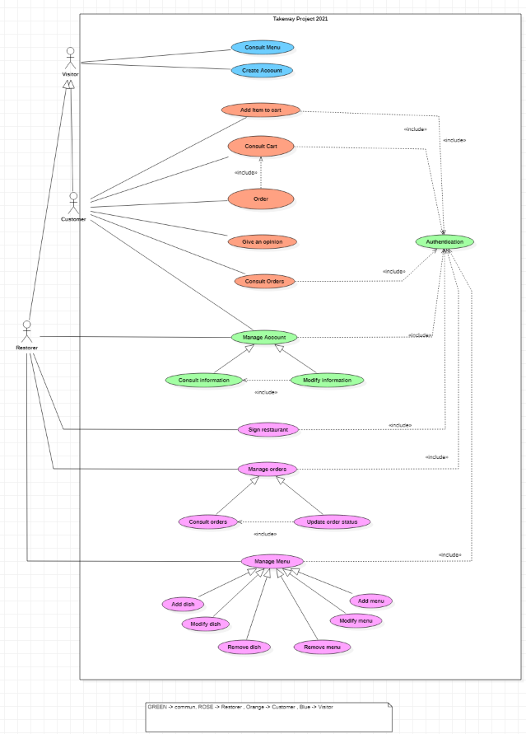

### Scénarios

|  |
| --- |
| ***Consult Menu***  **Identifier**:  UC_01  **Actors:**  Visitors and Customer  **Description:**  Everyone can consult menu, dishes, and global note.  **Preconditions:**   * 1. Application has been installed and launched.   2. Updated application.   3. Optional (authenticated).   **Assumptions:**   * 1. Network connexion established.   2. Database is online. ( if does it exist ? )   3. Restaurant and menus exist.   **Basic course:**  1. First screen: restaurant list.  User chooses the restaurant on the list and check the stars awarded to a restaurant.  2. Second screen: menus & dishes list. Applications displays all of menus and dishes, their brief descriptions and price. The user can check price of all menu or dishes. Also, he can check the overall rating and comments of other users about the restaurant.  3. Third screen: menu/dishes details. The user can check details of menu/dishes.  **Alternate course:**  **Case A:**  Database is offline.  Display error message.  **Case B:**  1. Button refresh has been selected.  Refresh list of Restaurant  **Case C:**  Screen 1/2/3. Users click on Sign-up  Go to CREATE ACCOUNT (UC_2 )  **Case D:**  Screen 1/2/3. Users click on Login  Go to AUTHENTICATION (UC_3 )  **Case E:**  2. URL comment selected.  Displays all of comments (box pop).  **Case F:**  Screen 2,3. Click on return  Go to Previous page.  **Case G:**  Screen 1,2,3. If the user is connected, adjust the page. |

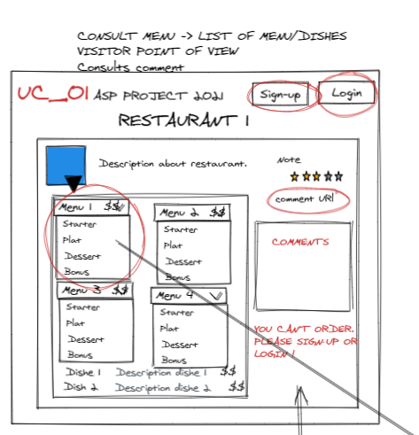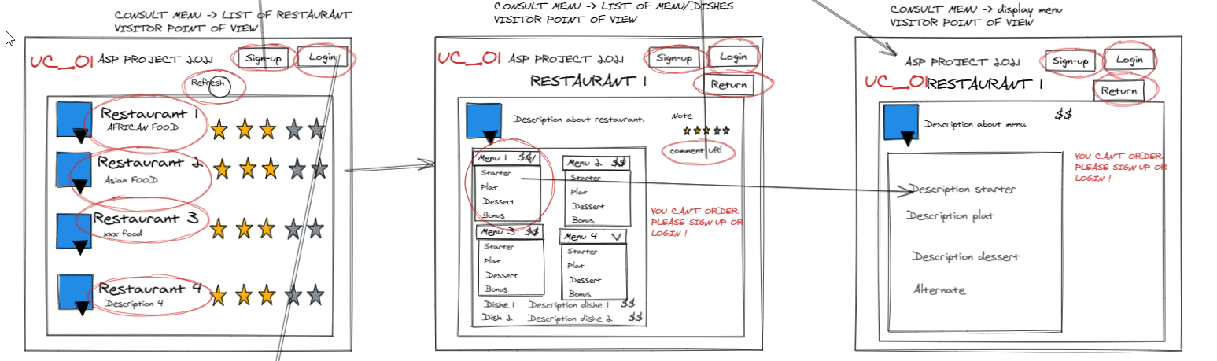

1 2 3

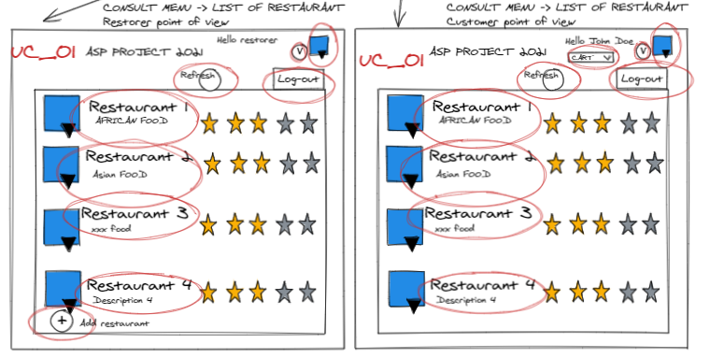

|  |
| --- |
| ***Create Account***  **Identifier**:  UC_02  **Actors:**  Visitor  **Description:**  In this use case, the visitor will create an account. He will have the choice between creating a restorer account or a customer account.  **Preconditions:**  The user is on the creating account page.  **Basic course:**  1. The visitor has the choice between a restorer or customer account.  2. In both account he will have to fill a form.  4. He clicks on the button “Validate” to validate the creation of account.  5. The account is created, and the user (restorer or customer) is connected.    **Alternate course:**  **Case A :**  2.The visitor chose the customer account.  3. He must fill a form (name, last name, email, address, phone  number, password, gender).    **Case B :**  2.The visitor has chosen the restorer account.  3. He must fill a form (name, last name, email, address, phone  number, TVA number, password).  6. A page appears to proposal to sign a restaurant: UC_12.  **Case C :**  2. The visitor decides to cancel the creation by clicking on a button.  **Case D:**  3. He must fill a form (name, last name, email, address, phone  number, TVA number, password).  4. He clicks on the button “Validate” to validate the creation of account.  5. The form is not correctly filled, the error(s) is/are pointed out. |

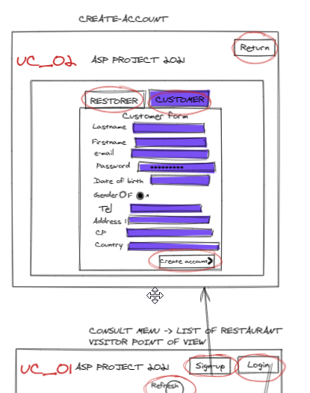

|  |
| --- |
| ***Authentication***  **Identifier**:  UC_03  **Actors:**  Visitor  **Description:**  The user can connect to the Application.  **Preconditions:**  1. UC_2  2. User clicked on “login” button on screen.  3. The user is on authentication page and has chosen the form (Customer or Restorer?)  **Assumptions:**  1. Network connexion established.  **Basic course:**  1. User type his e-mail and password account on form on authentication page.  2. Information are checked if the user password and the mail are correct. Also check if the person is a restorer or a costumer  3. User is connected as first name & last name  4. Go to main screen (list of restaurants)  **Alternate course:**  **Case A:**  2. Username is incorrect  Display the error message « Your username doesn’t exist. »  **Case B:**  2. Password is incorrect  Display the error message « Your password is incorrect. »  **Case C:**  2. Username & password are correct AND the type of account is CUSTOMER  4.Connected as CUSTOMER  **Case D:**  2. Username & password are correct AND the type of account is RESTORER  4.Connected as RESTORER  **Case E:**  Button return has been selected.  Go to main screen.  **Case F:**  Button “forgot password” pressed.  The user will receive an email to reset the password.  **Case G:**  Button “logout” pressed everywhere in the application when the user is connected.  Disconnect the user.  **Inclusion cases**  Add Item to cart (UC_04)  Consult Cart (UC_05) Manage account (UC_09) Sign restaurant (UC_12) |

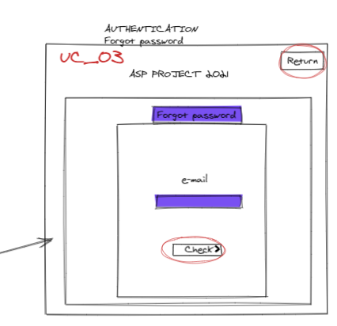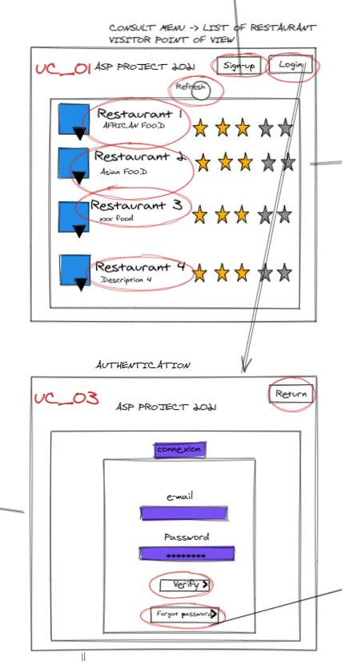

|  |
| --- |
| ***Add Item to cart***  **Identifier**:  UC_04  **Actors:**  Customer  **Description:**  The aim of this use case is to add an item to the cart.  **Preconditions:**  The user is authenticated.  **Basic course:**  1. The customer is consulting the menu and decide to add an item to the cart.  2. He clicks on the “add to cart” button.  3. The item is added to the cart    **Alternate course:**  4. The customer decides to remove the/an item of the cart 🡪 UC_05  **Inclusion cases:**  UC_03: Authentication. |

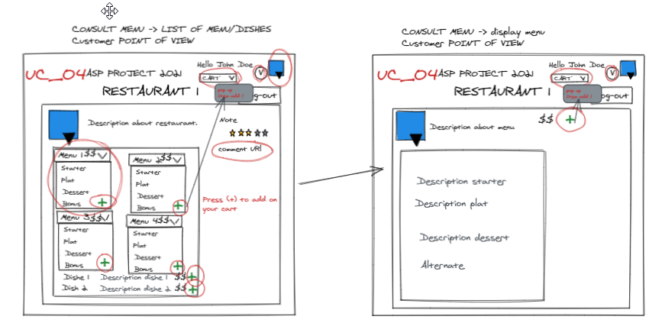

|  |
| --- |
| ***Consult Cart***  **Identifier**:  UC_05  **Actors:**  Customer  **Description:**  The customer can check his cart at every moment or page.  **Preconditions:**  1. Customer authenticated. 2. Customer is on cart screen  **Assumptions:**  1. Network connexion established.  **Basic course:** 1. The total price is automatically calculated.  2. Customer can quickly check the content of his cart on the cart page.  3. Customer pass his order if his cart satisfying him. Go to Order screen.  **Alternate course:**  **Case A:**  1. Customer press (-) button.  Delete one item on the cart.  **Case B:**  2. Customer press “select all”  All the items on the cart are selected.  **Case C:**  2. Customer press “delete all” (select all activated)  All the items on the cart are delete. Price is recalculated.  **Case D:**  2. Customer selected many items and click on delete.  The items selected on the cart are delete. Price is recalculated.  **Case E:**  2. Customer selected many items and click on delete.  The items selected on the cart are delete. Price is recalculated.  **Case F:**  Button return has been selected.  Go to main screen.  **Inclusion cases**  Authentication (UC_03)  Order (UC_06) |

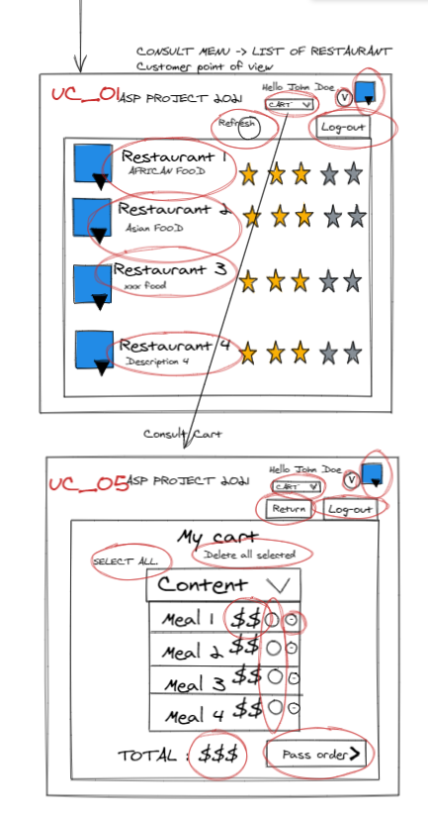

|  |
| --- |
| ***Order***  **Identifier**:  UC_06  **Actors:**  Customer  **Description:**  In this use case, the user will order what he has added to his cart.  **Preconditions:**  The cart is not empty.  **Basic course:**  1. The customer can validate his cart by clicking on a button.  2. A new page summarizes the order and asks for which address is this order  (the account address or another address).  3. The customer validates the order by clicking on a button.  4. A new page confirm that the order is validated and on this page the customer  can leave a comment and note the restaurant (with stars or numbers) ->  UC_07.  **Alternate course:**    **Case A :**  1. The customer can come back to the menu (to add item for example) by clicking on a button.  2. He is back on the menu page.  **Case B :**  3. The customer decides to cancel the order validation by clicking on a  button.  4.The customer is back on the cart page.   **Case C :**  3. The user chose to use another address rather than the account  address, so a form appears to enter the delivery address.  **Inclusion cases:**  UC_05: Consult cart  **Extension cases:**  UC_07: Give an Opinion |

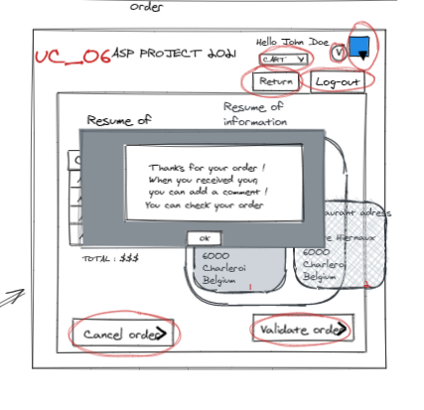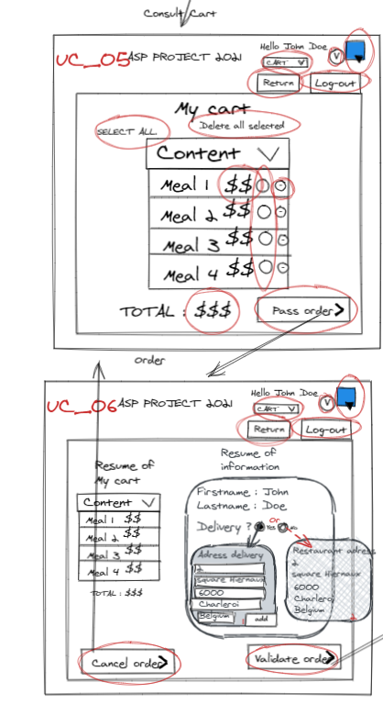

|  |
| --- |
| ***Give an opinion***  **Identifier**:  UC_07  **Actors:**  Customer  **Description:** After an order, a customer can give an opinion about a restaurant. For each order it is possible to leave a comment.  **Preconditions:**  1. Order UC_06 2. Order verified.  3. The customer should have at least one order in this restaurant.  **Basic course:** 1. Customer is on list of menu/dishes screen.  2. Customer click on (+)” add comment” button.  3. A windows pop.  4. The customer can type his opinion and choose number of stars and send.  5. Global note (stars) is recalculated.  6. The application knows that a comment has already been given for this order.   7. The message is saved and appears with the other comments. Return to the list of menus/dishes.  **Alternate course:**  **Case A:**   * 1. Stars field is empty.   Display error message.  **Case B:**  4. Press [X] on comment screen.  Quit comment screen and return at list of menus/dishes.  **Case C:**  Button return has been selected.  Go to main screen. |

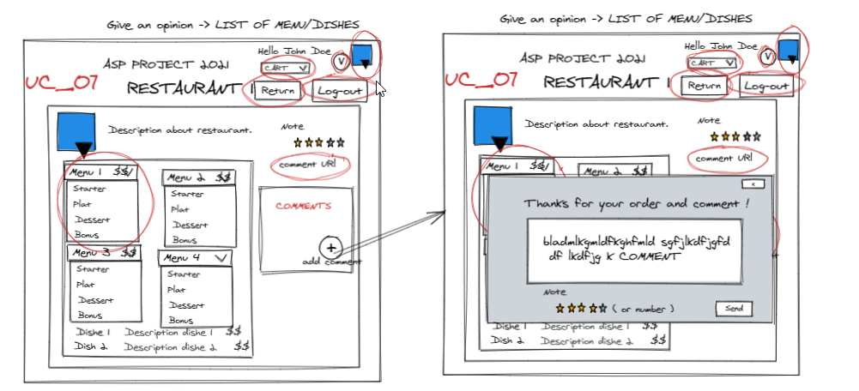

|  |
| --- |
| ***Consult orders***  **Identifier**:  UC_08  **Actors:**  Customer  **Description:**  The customer can check his order on going and old order.  **Preconditions:**   1. Customer has been clicked on option button next to his name and has chosen “consult order”  **Basic course:**   1. Customer is on consult order screen. 2. The application generates/searches the order for this customer and displays. 3. Customer can check his order.     **Alternate course:**  **Case A:**  An order is finished when the customer check his order on going.  The application updates the information. Order on going will be on old order.  **Case B:** The customer click button  The list of order is order by date of order.  **Inclusion cases:**  UC_03 (Authentication) |

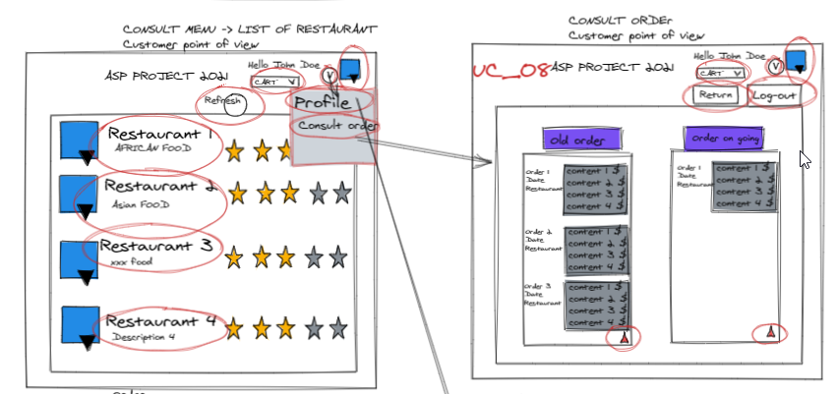

|  |
| --- |
| ***Manage account***  **Identifier**:  UC_09  **Actors:**  Customer, restorer  **Description:**  In this use case, the user can modify/consult information about his account.  **Preconditions:**  The user is on the manage account page (by clicking on his name in the upper right corner).  **Basic course:**  1. The user can consult and by this way modify his information.  **Alternate course:**  **Case A :**  1. The user wants to come back to the previous page by clicking on  The return buttons.    **Case B :**  2. The user decides to consult his information -> Go to UC_10 (Consult  Information)  **Inclusion cases:**  UC_03: Authentication |

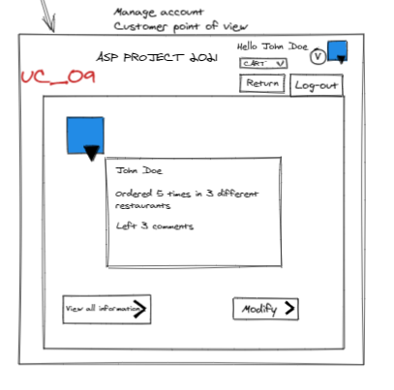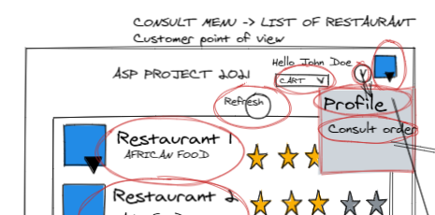

|  |
| --- |
| ***Consult Information***  **Identifier**:  UC_10  **Actors:**  Customer, restorer  **Description:**  In this use case, the user can see all the information that he has entered during the registration.  **Basic course:**  1. The user can consult the information that he has entered during the  Registration (name, last name, address, phone number).    **Alternate course:**  **Case A :**  1. The user wants to come back to the previous page by clicking on  the comeback buttons.    **Case B :**  2. The user decides to modify the information by clicking on the modify  button 🡺 Go to UC_11(Modify Information) |

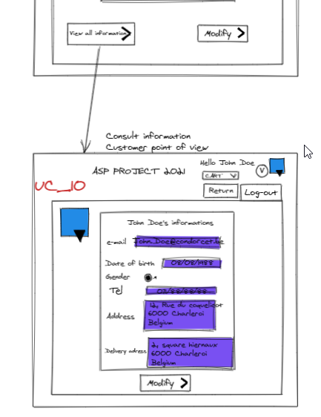

|  |
| --- |
| ***Modify Information***  **Identifier**:  UC_11  **Actors:**  Customer, restorer  **Description:**  In this use case, the user can modify all the information that he has entered during the registration.  **Preconditions:**  The user has clicked on a button to modify the information on the consult information page.  **Basic course:**  1. The user can modify the information that he has entered during the  Registration (name, last name, address, gender, phone number).  2. The user modifies the information that he wants.  3. The user validates the modifications by clicking on a button.  4. The modifications have been validated.    **Alternate course:**  **Case A:**  1. The user wants to come back to the previous page by clicking on  the comeback buttons.  2. The user is back on the previous page.  **Case B:**  3. The user wants to cancel the modifications by clicking on  a button.  4. The user is redirected on the consult page.    **Case C:**  4. An alert (or something else) confirms that the modification failed with  the details of the errors (and pointing out the error(s))  **Inclusion cases:**  UC_10 : Consult information |

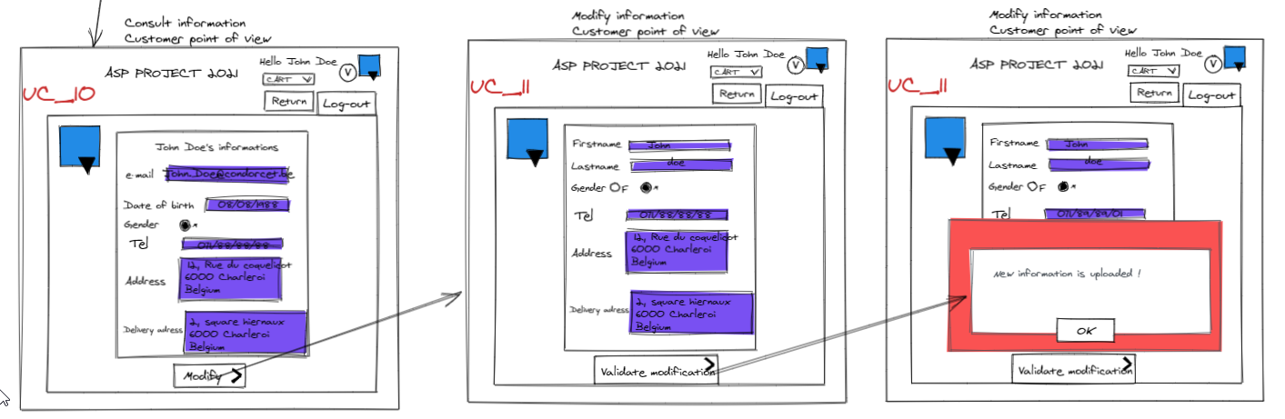

|  |
| --- |
| ***Sign Restaurant***  **Identifier**:  UC_12  **Actors:**  Restorer  **Description:**  The restorer can add his restaurant on the list. It is possible to add several restaurants for a restorer.  **Preconditions:**  1. Restorer authenticated. 2. Clicked on “add restaurant” on consult menu screen while being Restorer account.  **Basic course:** 1. The restorer types the name, the address (cp/country/), the restaurant telephone, the type of food and a description on the “add restaurant form”  2. The restorer clicks on “add restaurant”.  3. Verification of data field.  4. The information is saved, and increment ID created  5. The restaurant is added to the list and the restorer and the application go to the list of restaurant screen.  **Alternate course:**  **Case A:**  3. Field entered incorrect or empty  Display error message and ask to restorer to enter information.  **Inclusion cases**  Authentication (UC_03)  Manage order (UC_13) Manage Menu (UC_16) |

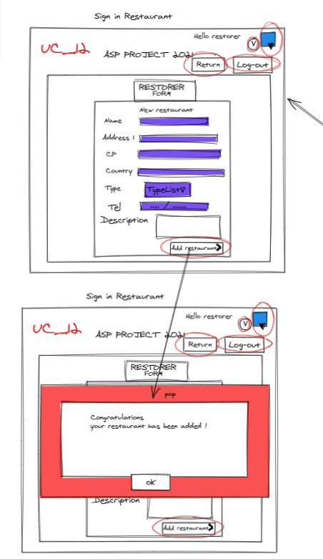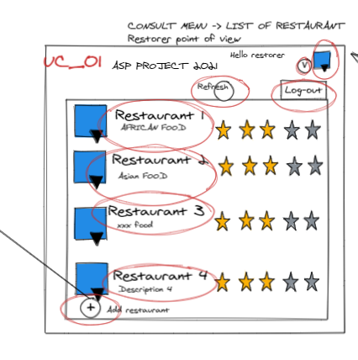

|  |
| --- |
| ***Manage Orders***  **Identifier**:  UC_13  **Actors:**  Restorer  **Description:**  This use case is aimed to manage the orders that the restaurant received.  **Preconditions:**  The restaurant is signed.  **Basic course:**   * + 1. The restorer chooses his restaurant if he has several.     2. The restorer chooses to consult the orders -> UC_12(Consult orders)     **Alternate course:**    **Case A:**  1.The user can come back to the previous page by clicking on a button.    **Inclusion cases:**  UC_12: Sign Restaurant |

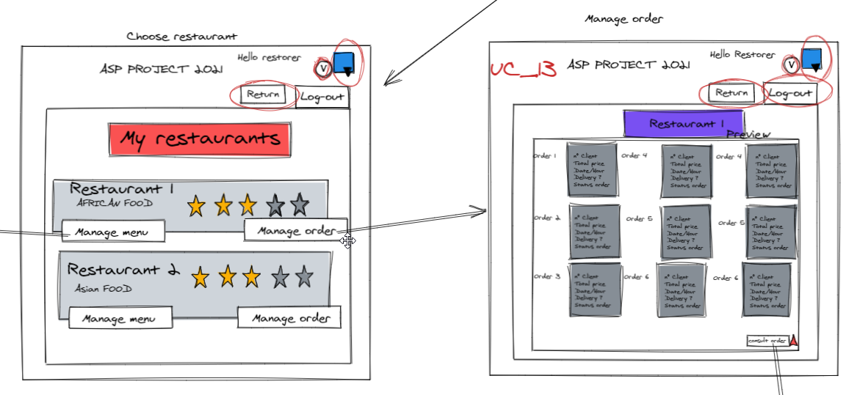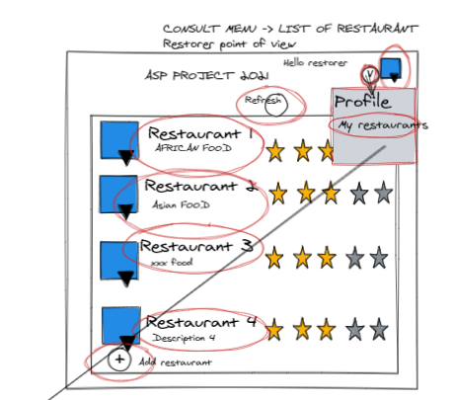

|  |
| --- |
| ***Consult Orders***  **Identifier**:  UC_14  **Actors:**  Restorer  **Description:**  In this use case, the restorer can consult all the orders that his restaurant received. There are two different categories Recent orders (about the current day), All orders (historic).  **Preconditions:**  The restaurant is signed, and the user is on the consult order page.  **Basic course:**  1. The restorer can choose to see all the orders and see the recent  Orders and scroll the page.    **Alternate course:**  **Case A:**  2. The restorer chose to see all the orders by clicking on this possibility.  3. A page shows all the orders ordered by day and hour.  4. The restorer can manage the status of the order (only for the order of  the day)  🡪UC_13(Update Order Status).  5.The user can come back to the previous page by clicking on a button.  **Case B:**  2. The restorer chose to see the recent orders by clicking on  this possibility.  3. The restorer can manage the status of the order  -> UC_13(Update Order Status).  4.The user can come back to the previous page by clicking on a button.  **Case C:**  2.The user can come back to the previous page by clicking on a button.    **Inclusion cases:**  UC_11: Manage order |

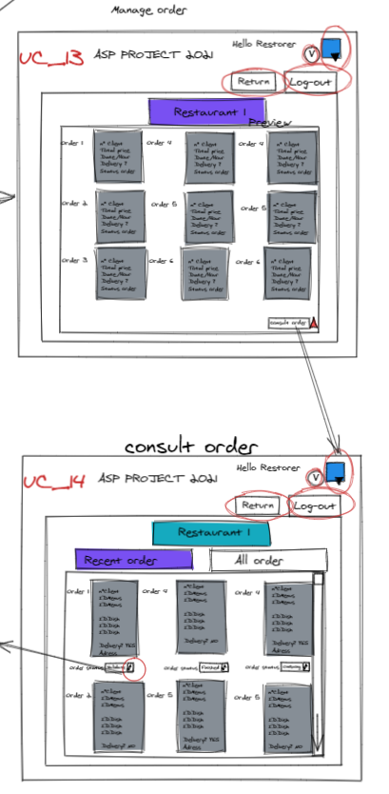

|  |
| --- |
| ***Update Order Status***  **Identifier**:  UC_15  **Actors:**  Restorer  **Description:**  In this use case, the restorer can update the order status (received, in progress, ready).  **Preconditions:**  The restaurant is signed, and the restorer is in the one of the consult pages.  **Basic course:**  1. The restorer can update the order status by three different states:   * + - Validate : the restaurant has received the customer order     - OnPreparation: the order is prepared     - OnDelivery : on delivery     - Finished : the order is ready for the client.   2. The restorer change the status by clicking on the corresponding state.  3. The status is updated.  **Alternate course:**    **Case A:**  1.The user can come back to the previous page by clicking on a button.  **Inclusion cases:**  UC_12: Consult Orders |

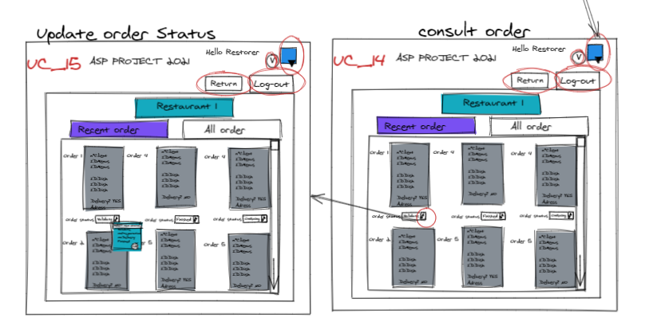

|  |
| --- |
| ***Manage menu***  **Identifier**:  UC_16  **Actors:**  Restorer  **Description:**  In this use case, the restorer can manage his menu by adding/ removing/ modifying his menu: dishes and menus. The restorer can also prepare the menus for the two services of the day.  **Preconditions:**  The restaurant is signed, and the restorer is on the menu management page.  **Basic course:**  1. The restorer can modify all the information about an item of the menu and  he can also prepare the menus for the two services of the day.    **Alternate course:**  **Case A:**  2.The restorer decides to add a dish by clicking on the adding  button.  3. The UC_17 (Add Dish) is called.  **Case B:**  2.The restorer decides to add a menu by clicking on the adding  button.  3. The UC_20 (Add menu) is called.  **Case C:**  2.The restorer decides to modify a dish by clicking on the modifying  button.  3. The UC_18 (Modify dish) is called.  **Case D:**  2.The restorer decides to modify a menu by clicking on the modifying  button.  3. The UC_21 (Modify Menu) is called.  **Case E:**  2.The restorer decides to remove a dish by clicking on the removing button  3. The UC_19(Remove dish) is called.  **Case E:**  2.The restorer decides to remove a menu by clicking on the removing  button  3. The UC_22(Remove menu) is called.  **Inclusion cases:**  UC_03- Authentication |

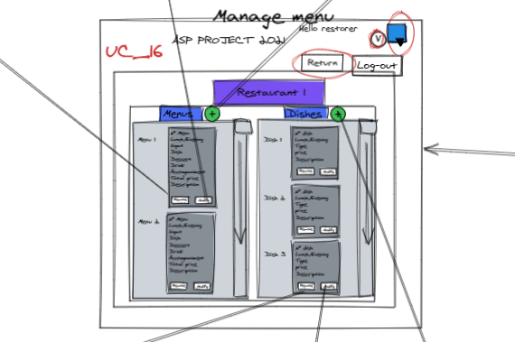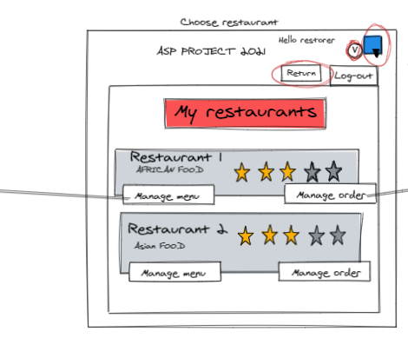

|  |
| --- |
| ***Add dish***  **Identifier**:  UC_17  **Actors:**  Restorer  **Description:**  In this use case, the restorer adds dish to his menu.  **Preconditions:**  The restaurant is signed, and the restorer is on the menu management page.  **Basic course:**  1. The restorer can add a dish by clicking on a button.  2. The restorer must fill a form: name, description, price, hour of service,  supplements (optional).  3. The restorer validates the adding of the dish.  4. The dish is added to the menu.  5. The restorer is back on the management menu page.  **Alternate course:**  **Case A:**  2.The restorer decides to cancel the adding by clicking on a button.  3. The restorer is back on the management menu page.    **Case B:**  3.The restorer decides to cancel the adding by clicking on a button.  4. The restorer is back on the management menu page.  **Case C:**  4. The adding failed because of error(s): the error(s) is/are pointed out.  5. The user corrects the error(s).  3. The restorer validates the adding of the dish.  4. The dish is added to the menu.  5. The restorer is back on the management menu page. |

|  |
| --- |
| ***Modify dish***  **Identifier**:  UC_18  **Actors:**  Restorer  **Description:**  In this use case, the restorer modifies dish from his menu.  **Preconditions:**  The restaurant is signed, and the restorer is on the menu management page.  **Basic course:**  1. The restorer can modify a dish by clicking on a button.  2. He can modify all the different information: name, price, description,  the supplements.  3. The restorer validates the modification(s) of the dish.  4. The dish is modified.  5. The restorer is back on the management menu page.  **Alternate course:**  **Case A:**  2.The restorer decides to cancel the modification by clicking on a button.  3. The restorer is back on the management menu page.    **Case B:**  3.The restorer decides to cancel the modification by clicking on a button.  4. The restorer is back on the management menu page.  **Case C:**  4. The modification failed because of error(s): the error(s) is/are pointed out.  5. The user corrects the error(s).  3. The restorer validates the modification(s) of the dish.  4. The dish is modified.  5. The restorer is back on the management menu page. |

|  |
| --- |
| ***Remove dish***  **Identifier**:  UC_19  **Actors:**  Restorer  **Description:**  In this use case, the restorer removes dish from his menu.  **Preconditions:**  The restaurant is signed, and the restorer is on the menu management page.  **Basic course:**  1. The restorer can remove a dish by clicking on a button.  2. The restorer validates the removal of the dish.  3. The dish is deleted.  4. The restorer is back on the management menu page.  **Alternate course:**  **Case A:**  2.The restorer decides to cancel the removal by clicking on a button.  3. The restorer is back on the management menu page. |

|  |
| --- |
| ***Add menu***  **Identifier**:  UC_20  **Actors:**  Restorer  **Description:**  In this use case, the restorer adds a menu to the restaurant menu.  **Preconditions:**  The restaurant is signed, and the restorer is on the menu management page.  **Basic course:**  1. The restorer can add a menu by clicking on a button.  2. The restorer must add dish to compose the menu, he can add supplements  (optional).  3. The restorer sets the normal price (without all the supplements).  3. The restorer validates the adding of the menu.  4. The menu is added to the restaurant menu.  5. The restorer is back on the management menu page.  **Alternate course:**  **Case A:**  2. The restorer decides to cancel the adding of a menu by clicking on a  button.  3. The restorer is back on the management menu page.    **Case B:**  3.The restorer decides to cancel the adding by clicking on a button.  4. The restorer is back on the management menu page.  **Case C:**  4. The adding failed because of error(s): the error(s) is/are pointed out.  5. The user corrects the error(s).  6. The restorer validates the adding of the menu.  7. The menu is added to the restaurant menu.  8. The restorer is back on the management menu page. |

|  |
| --- |
| ***Modify menu***  **Identifier**:  UC_21  **Actors:**  Restorer  **Description:**  In this use case, the restorer can modify a menu from his restaurant menu.  **Preconditions:**  The restaurant is signed and the restorer is on the menu management page.  **Basic course:**  1. The restorer can modify a menu by clicking on a button.  2. He can modify all the different information: dishes inside, price,  the supplements.  3. The restorer validates the modification(s) of the menu.  4. The menu is modified.  5. The restorer is back on the management menu page.  **Alternate course:**  **Case A:**  2.The restorer decides to cancel the modification by clicking on a button.  3. The restorer is back on the management menu page.    **Case B:**  3.The restorer decides to cancel the modification by clicking on a button.  4. The restorer is back on the management menu page.  **Case C:**  4. The modification failed because of error(s): the error(s) is/are pointed out.  5. The user corrects the error(s).  3. The restorer validates the modification(s) of the menu.  4. The menu is modified.  5. The restorer is back on the management menu page. |

|  |
| --- |
| ***Remove menu***  **Identifier**:  UC_22  **Actors:**  Restorer  **Description:**  In this use case, the restorer removes menu from his restaurant menu.  **Preconditions:**  The restaurant is signed, and the restorer is on the menu management page.  **Basic course:**  1. The restorer can remove a menu by clicking on a button.  2. The restorer validates the removal of the menu.  3. The menu is deleted.  4. The restorer is back on the management menu page.  **Alternate course:**  **Case A:**  2.The restorer decides to cancel the removal by clicking on a button.  3. The restorer is back on the management menu page. |

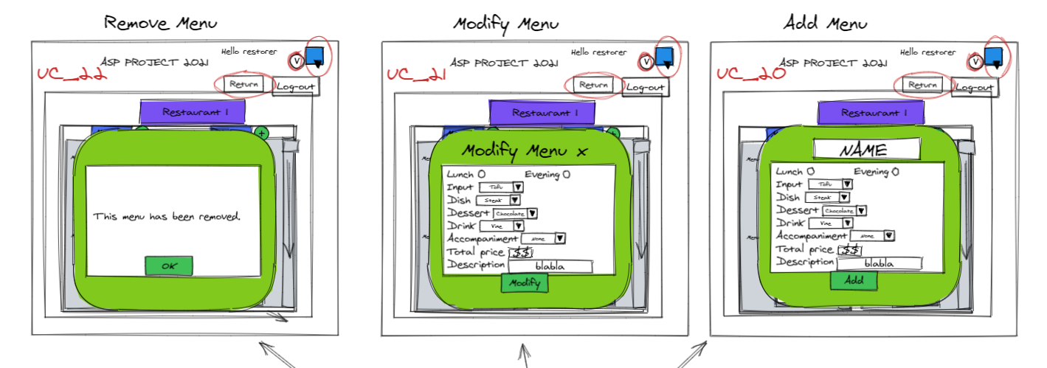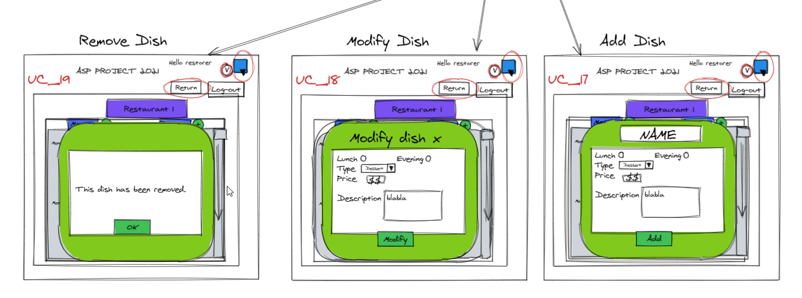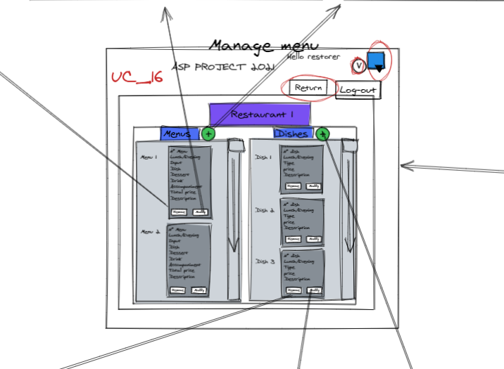

## Class diagram

### Préambule

Le diagramme de class permet de déterminer la structure du programme et les associations entre les classes. Ainsi, les classes présentent leur comportement (méthodes) et leur type de manière statique.

### JET 1 présenté ( 02-04)

#### Commentaires reçus lors de la réunion

Niveau des attributs   
On met l’attribut d’une autre class -> Ex : Un menu a une liste de plat, mais il n’y a pas besoin de préciser qu’il y a une liste dedans. Idem référence simple !!! Pas besoin !!  
Opinion -> Customer !!! Attention pour lancer la méthode. GiveAnOpinion() Bidirectionnel  
Multiplicité facultative lorsque composition   
Account : pas besoin de l’énum dans les class. Retirer l’attribut de account et le mettre dans customer !! date de naissance restaurateur ? Vais-je m’en servir ?   
Au niveau des dish et menu -> MIEUX LE POLYMORPHISME !!  
ID : pas comme dans la base de données. Gérer l’incrémentation par la base de données ! Il va de toute façon stocker la manière de s’authentifier dans la BDD.   
Représenter une liste d’heure : avec tableau mieux. [0..*] [2] pour le tab Renommer openingHoursLe n°TVA c’est lié à une entreprise donc dans le restaurant. Les compositions et agrégation sont aussi navigables, dans un sens. On pourrait avoir besoin d‘une flèche du côté agrégation.

### Jet 2

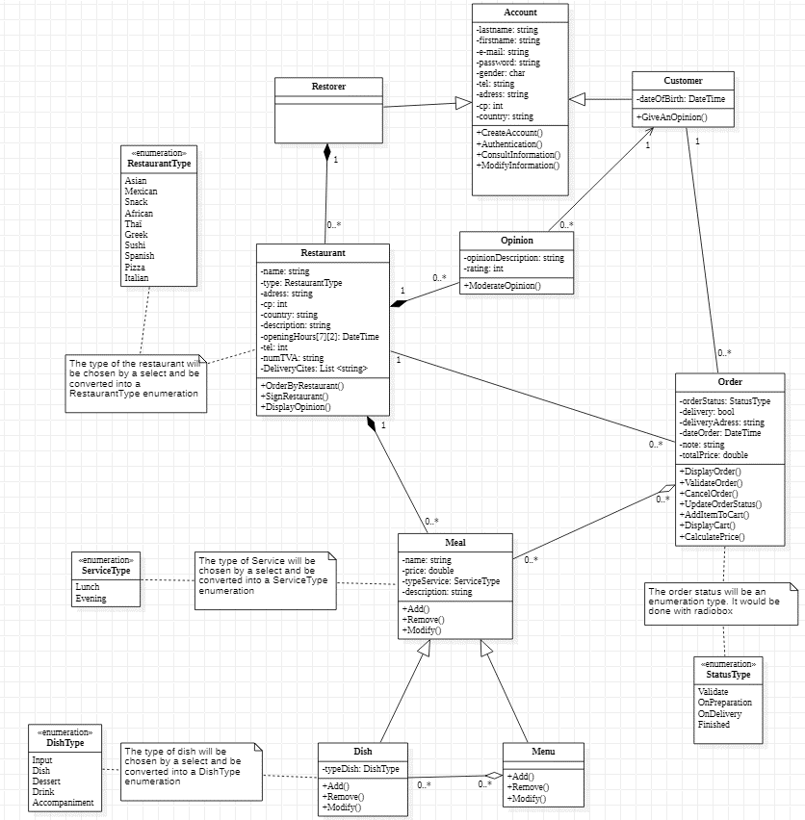

#### Commentaire de l’enseignant

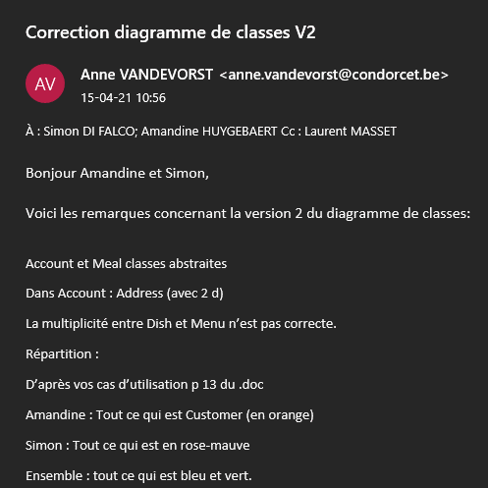

### Jet 3

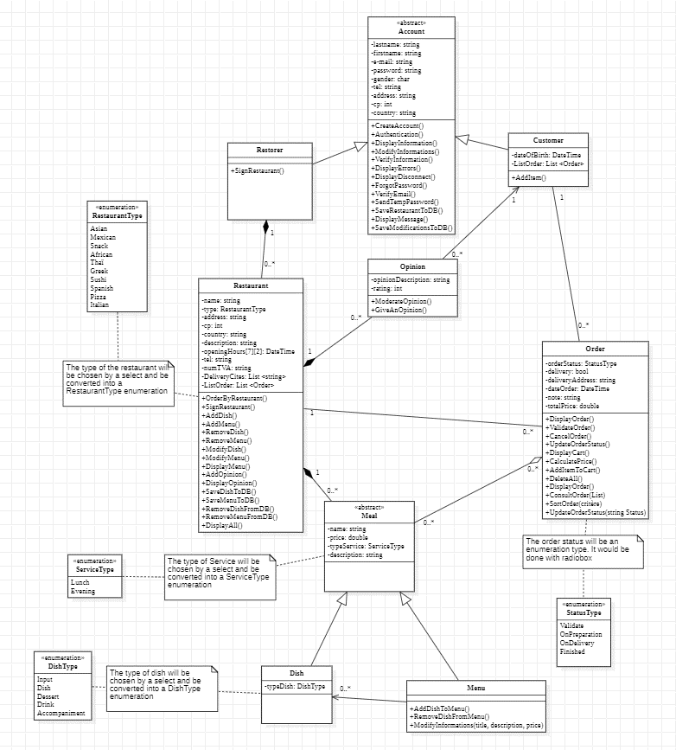

### Jet 4

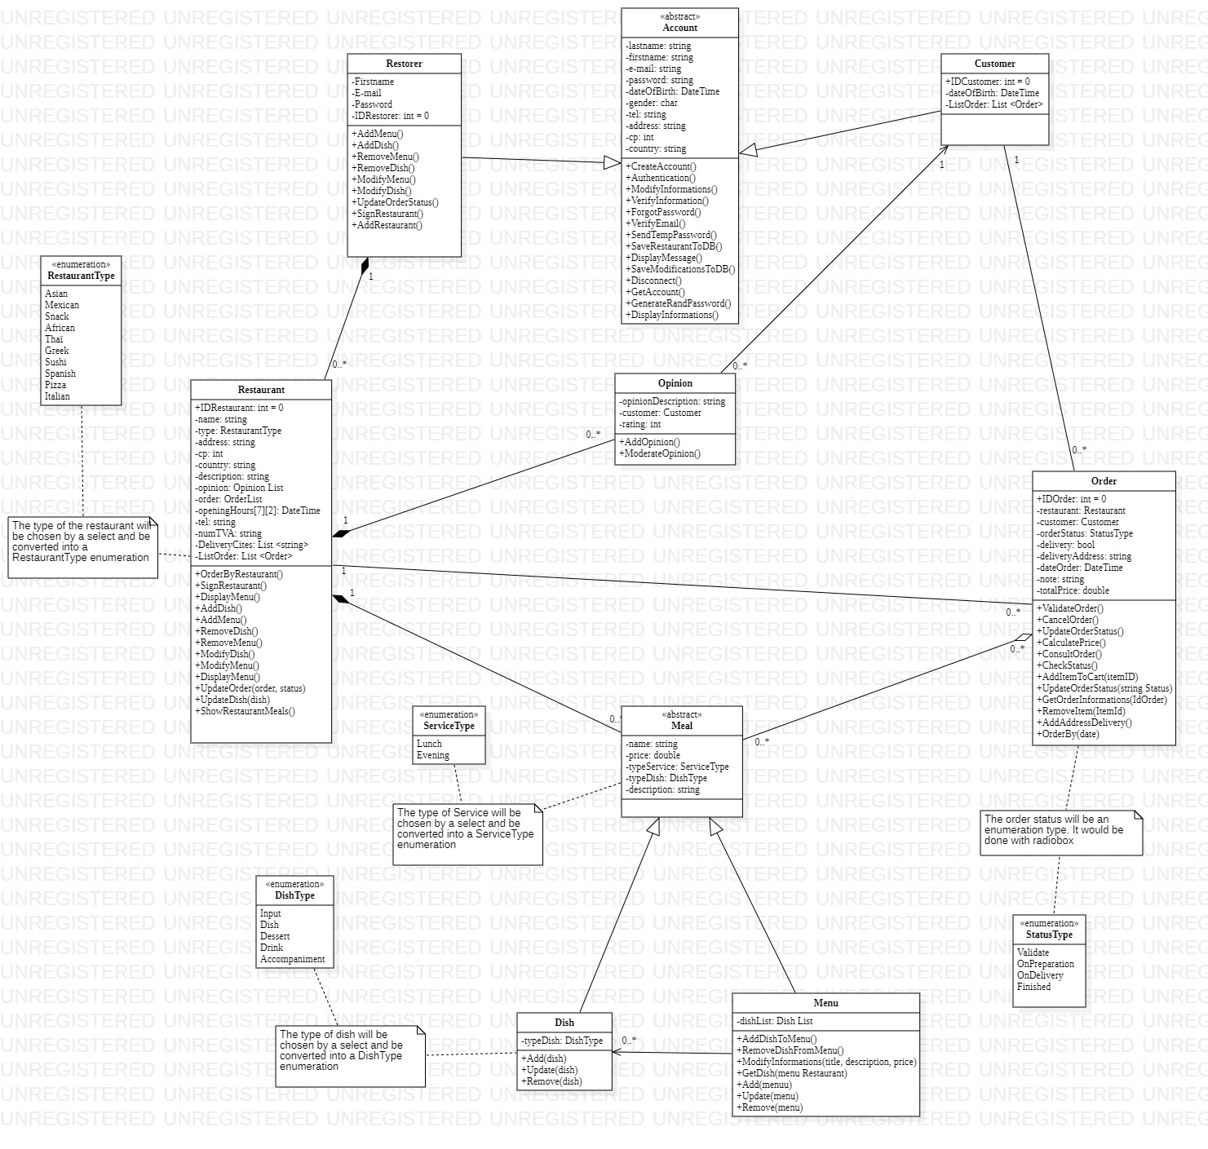

### Jet 5

### Jet final

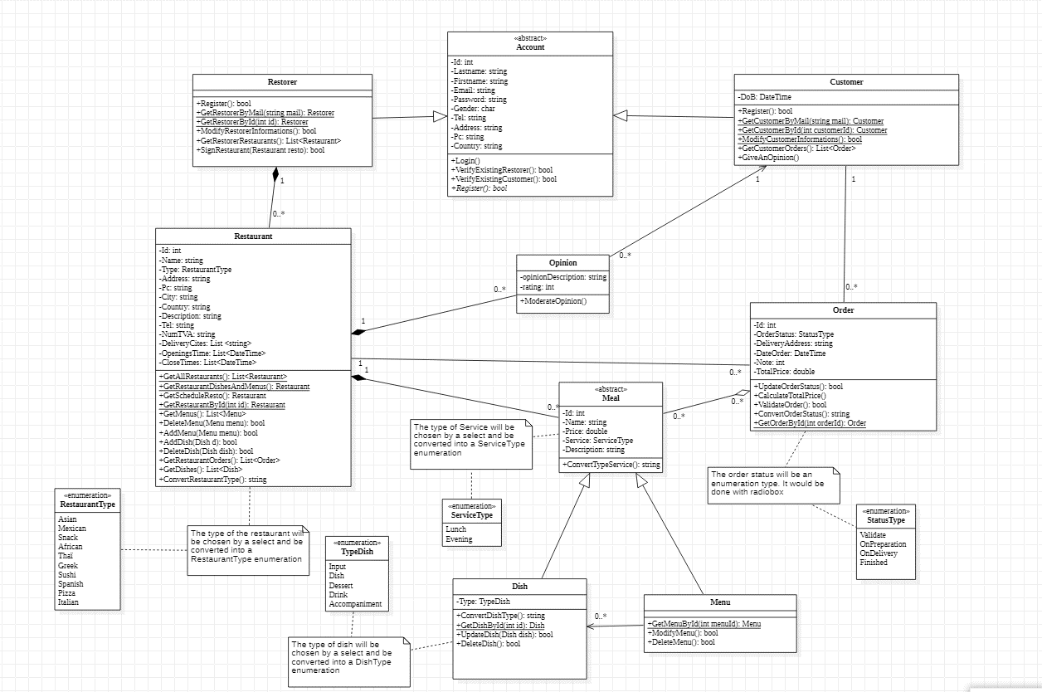

### Version août

#### Remarque

* Les liens unidirectionnels posent problème. Il n’est plus possible de retrouver le client ou le restaurant ayant passé commande puisqu’il n’y a plus de référence. Dans le controleur, le problème était facilement réglé : il suffisait de manipuler la session. En revanche, ça n’est pas possible dans la DAL. Le lien unidirectionnel dans l’autre sens aurait également son lot de problème. Le restaurant ne possèderait plus sa liste de commande, ni le client.

C’est pourquoi je reprends l’idée des liens bi-directionnels.

### Version 2 août

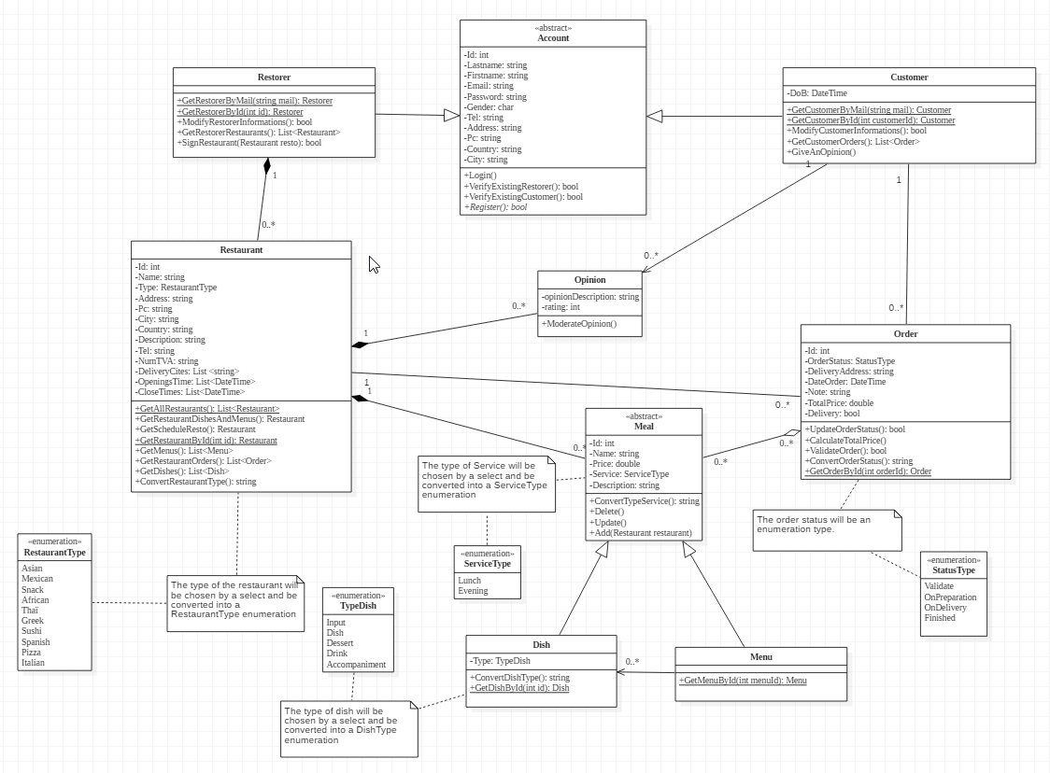

## Sequence diagram

### Préambule

Le diagramme de séquence sert à visualiser sur un temps donné (scénario de cas d’utilisation) les interactions entre les objets d’un programme.

### Diagrammes de séquence Jet 1

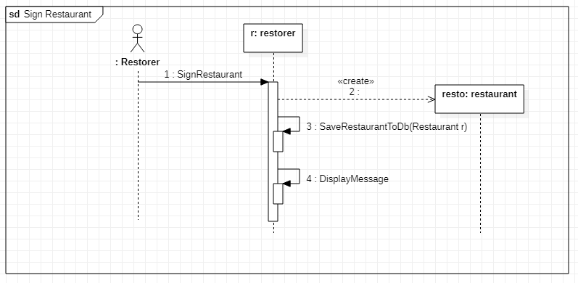

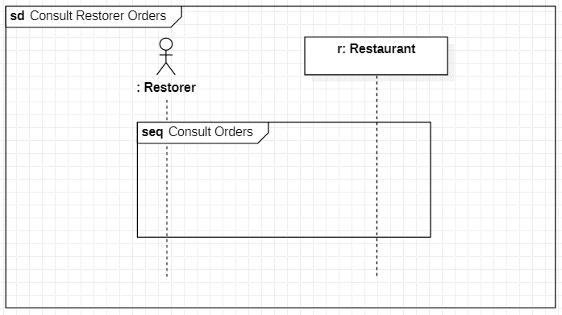

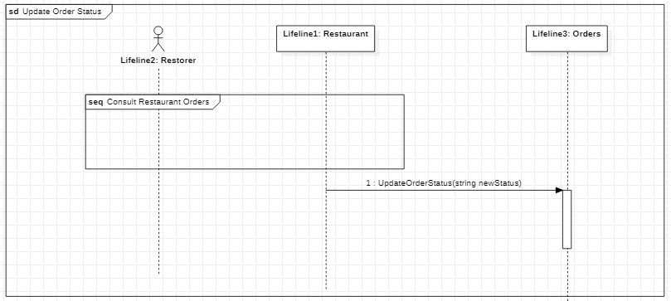

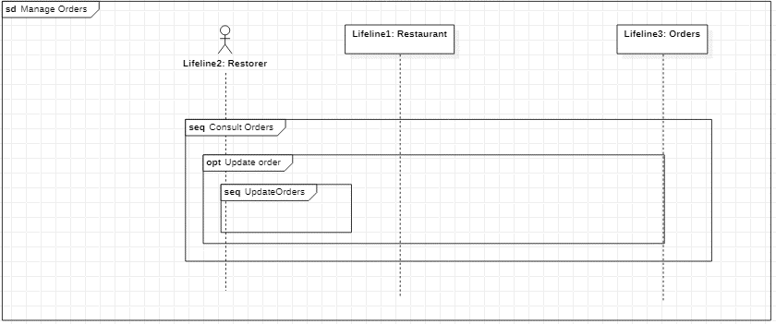

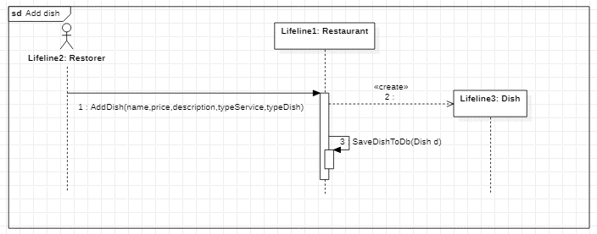

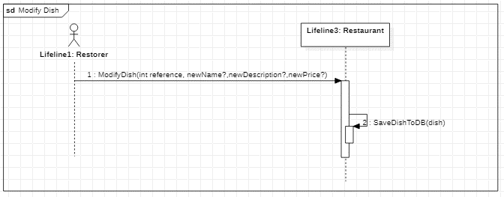

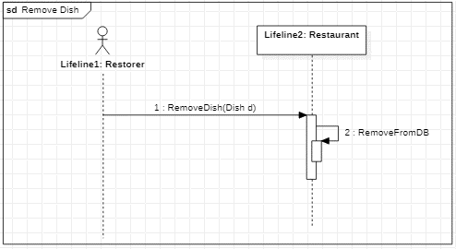

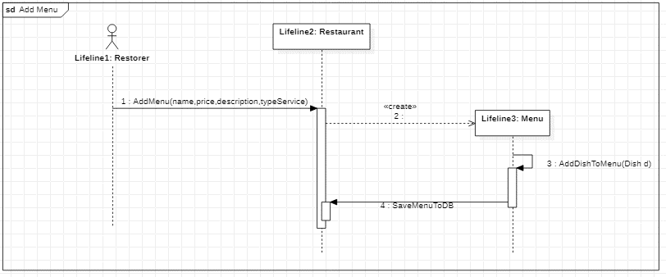

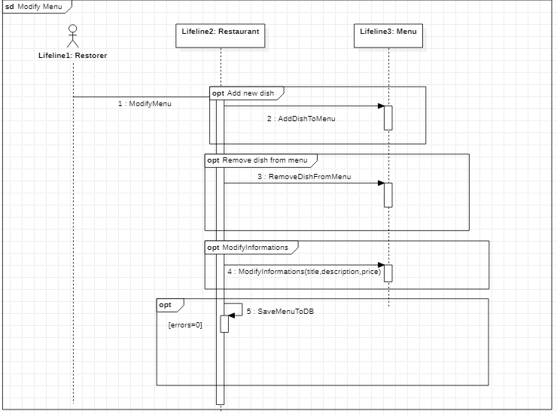

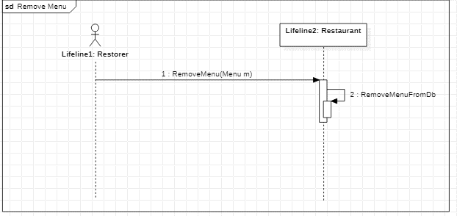

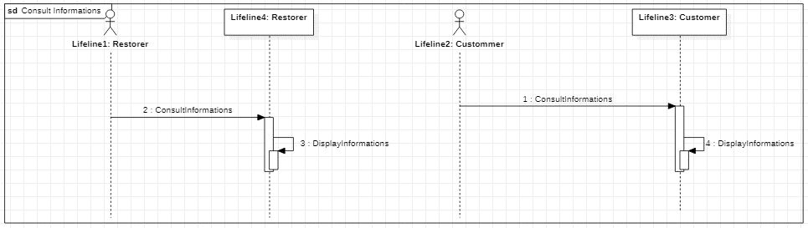

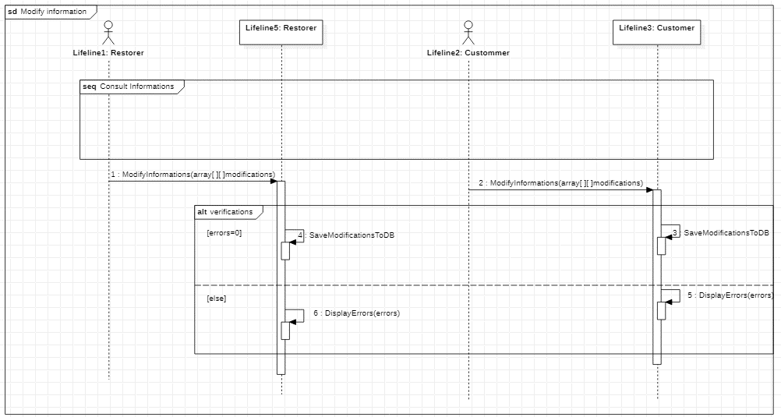

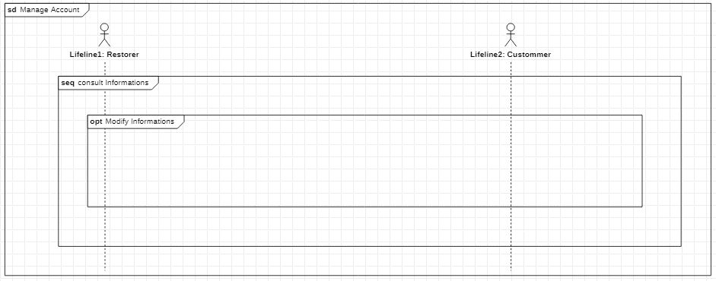

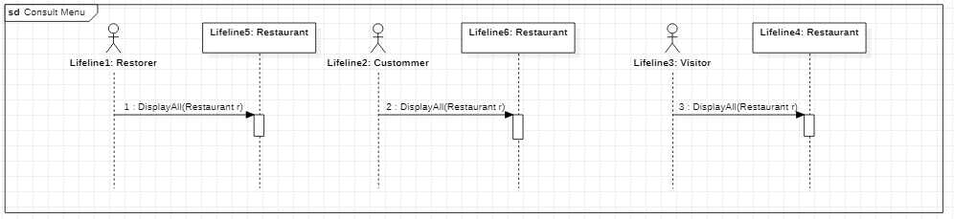

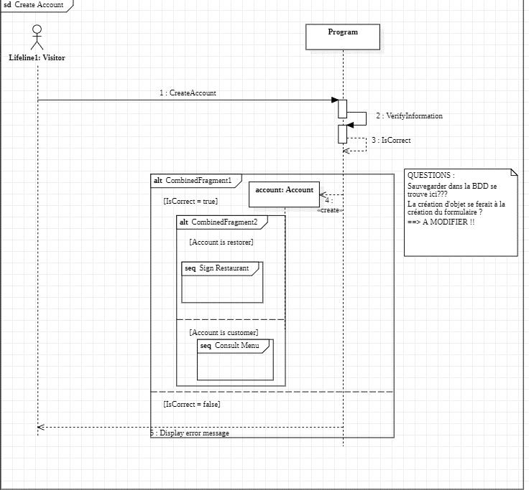

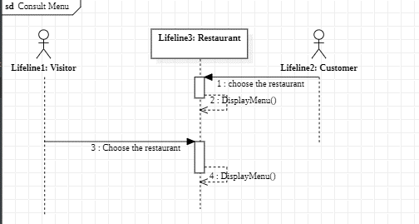

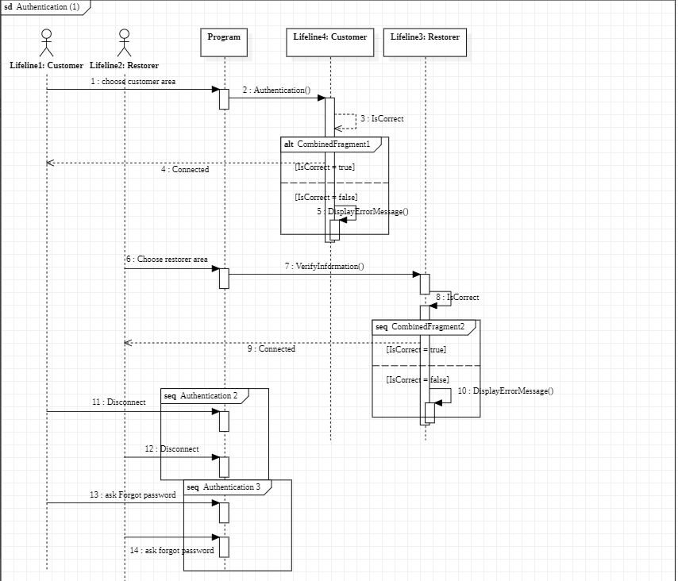

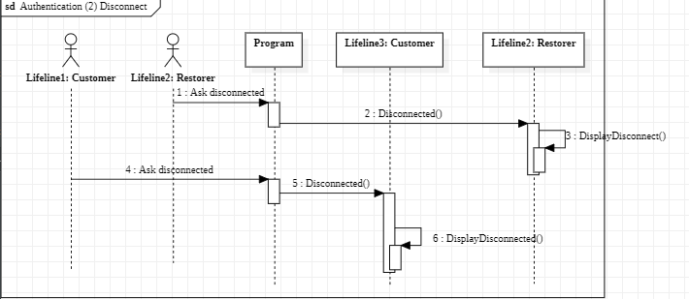

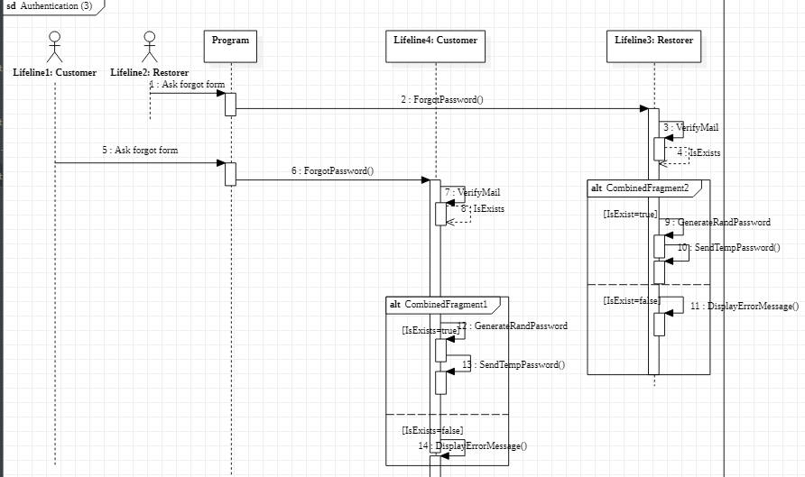

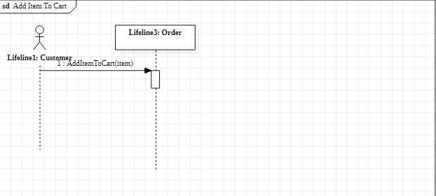

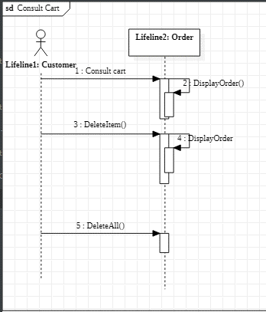

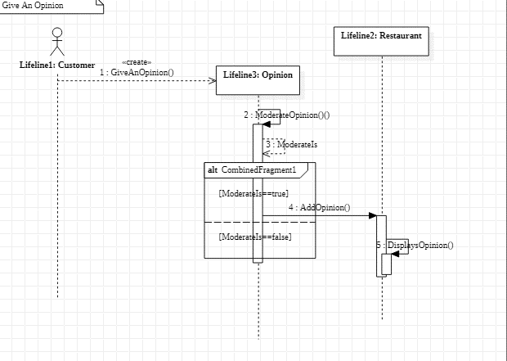

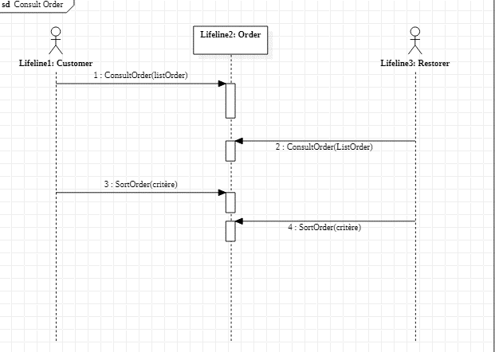

#### Commentaires

Cours de rattrapage avec Mr Masset car les diagrammes de séquence n’étaient pas bons.

### Jet 2

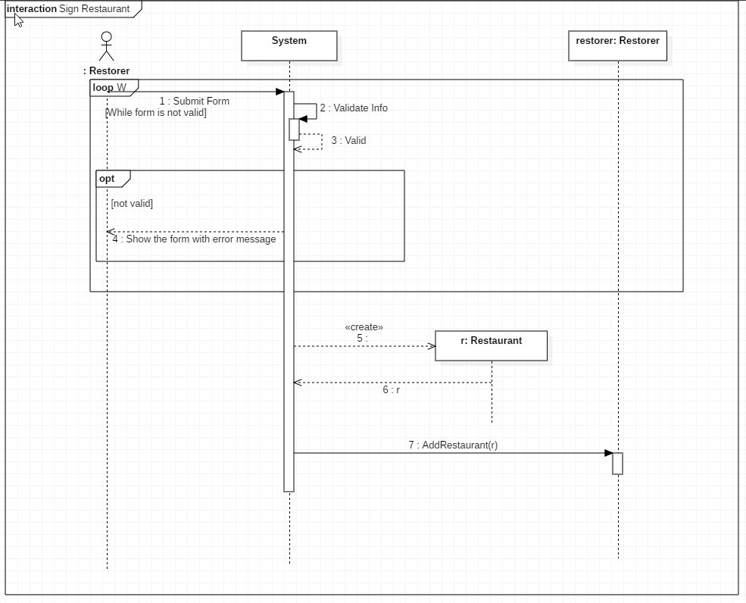

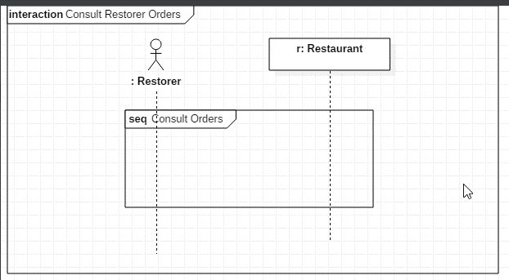

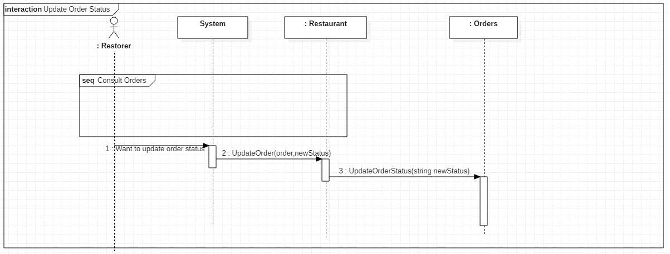

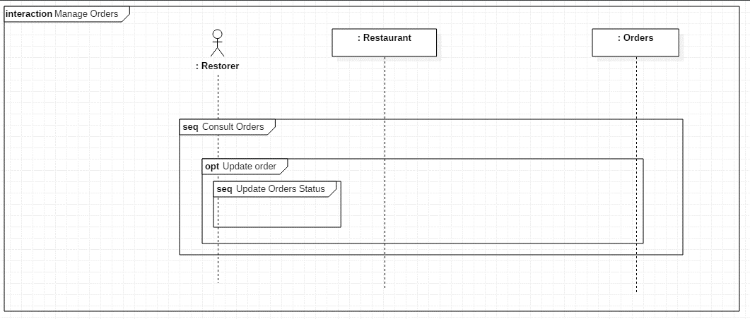

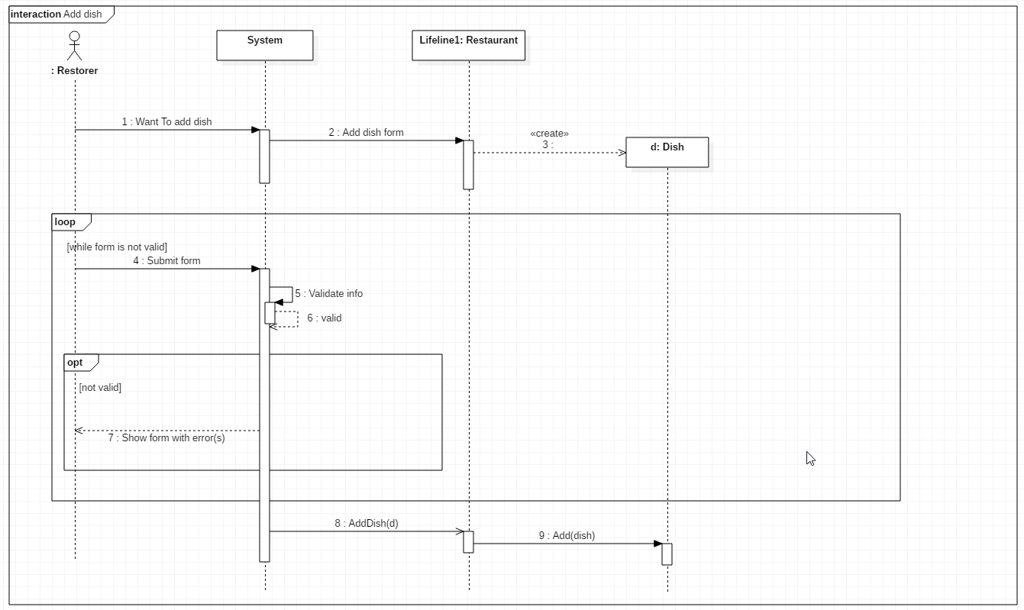

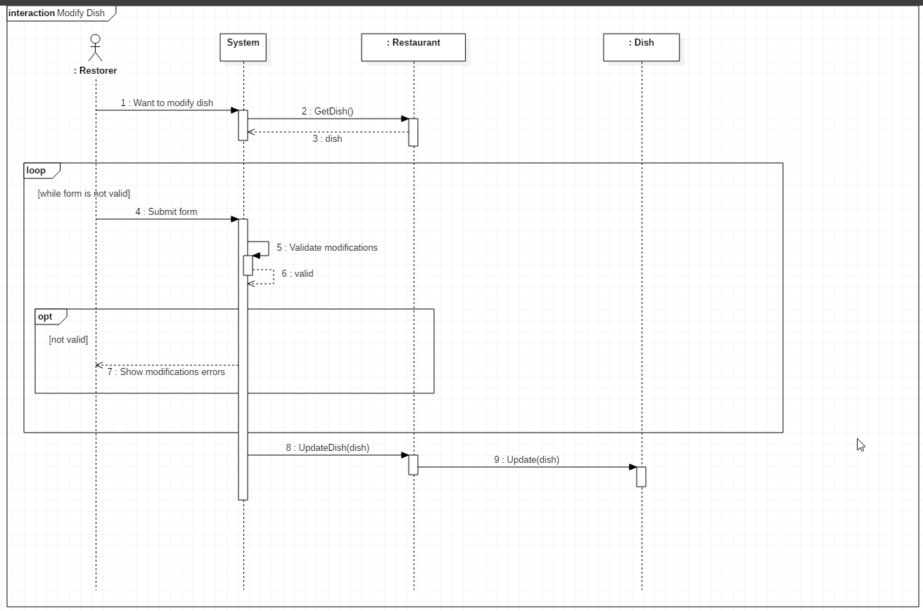

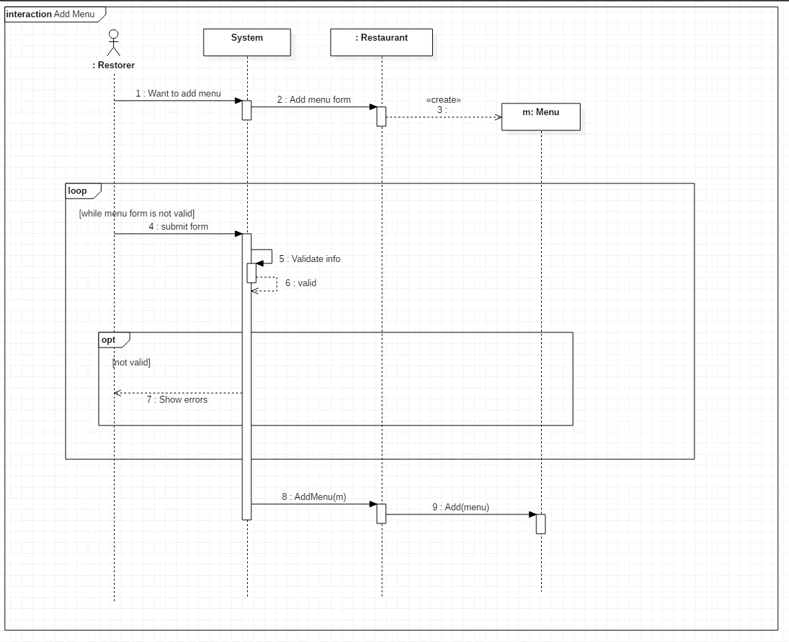

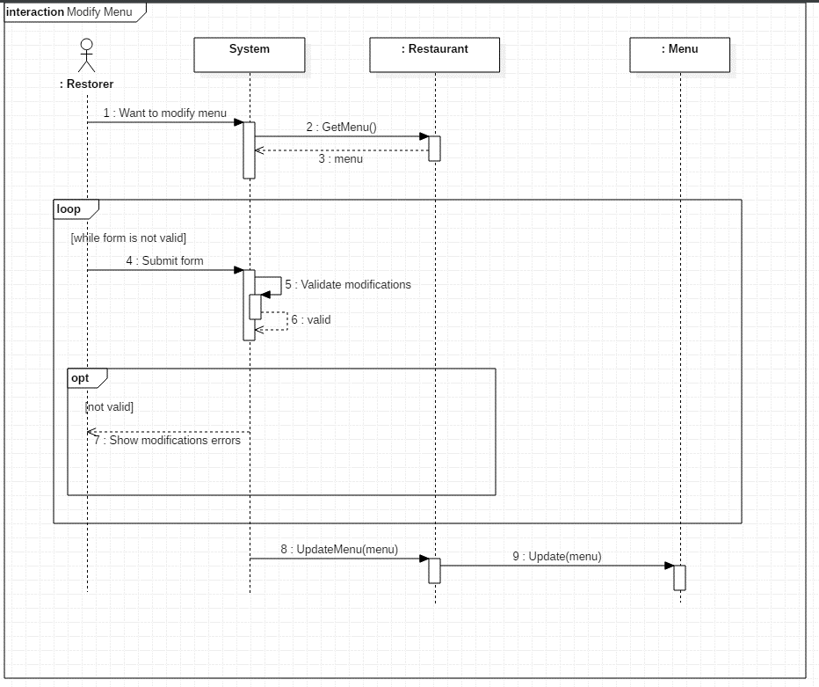

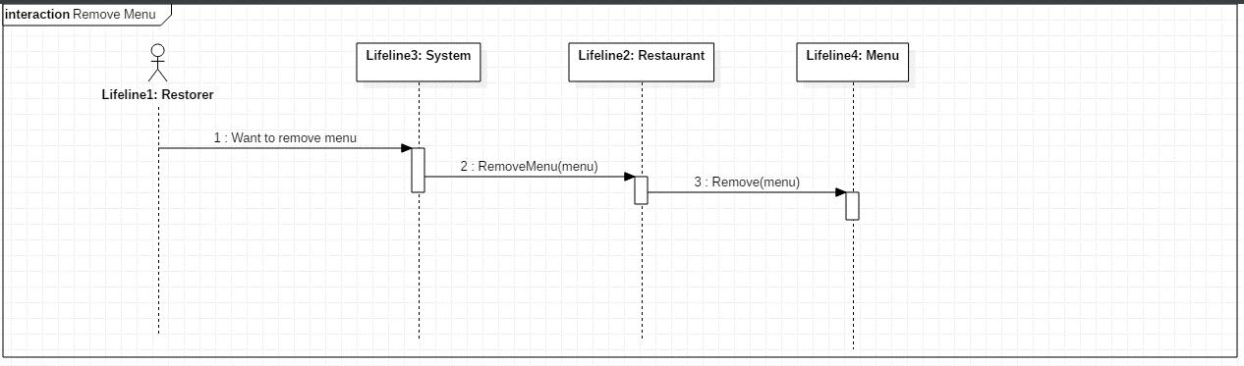

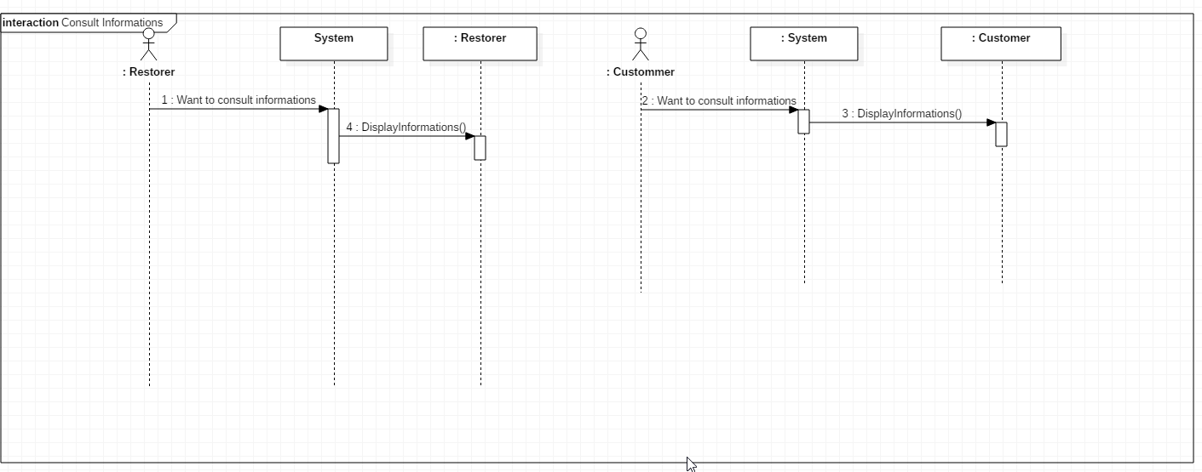

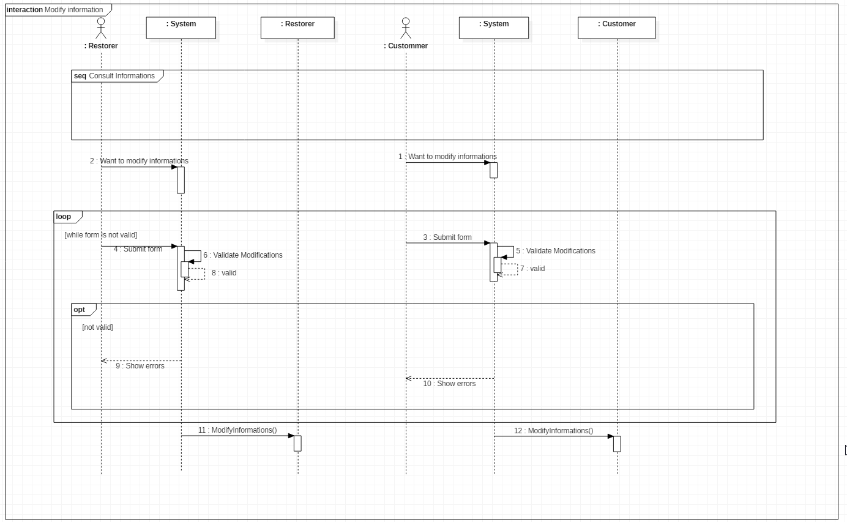

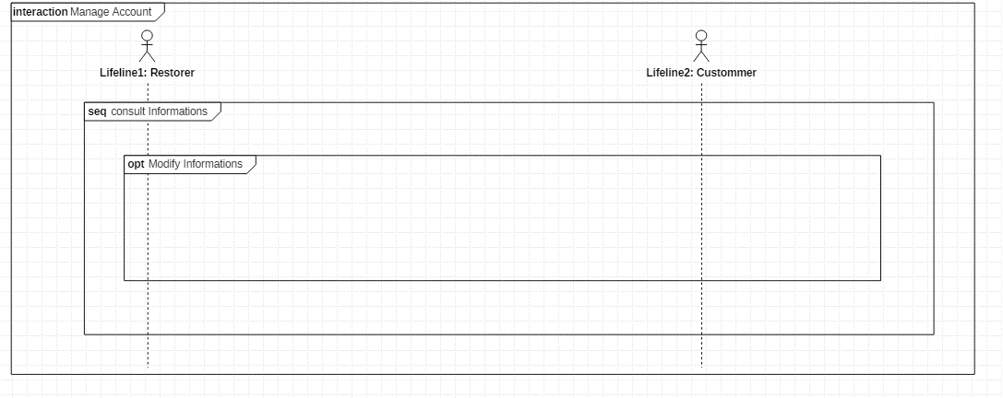

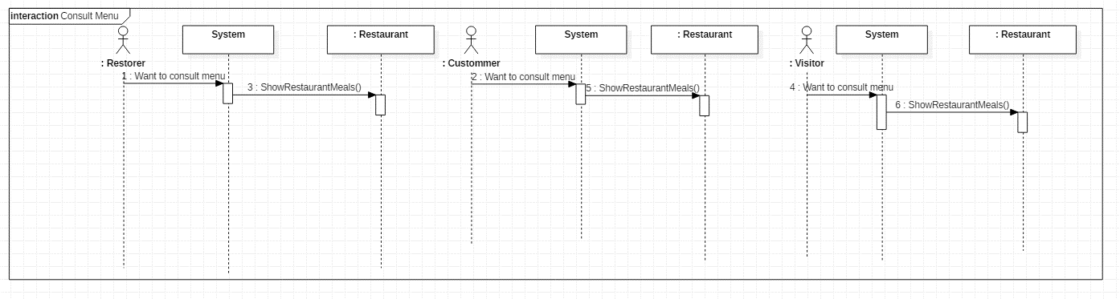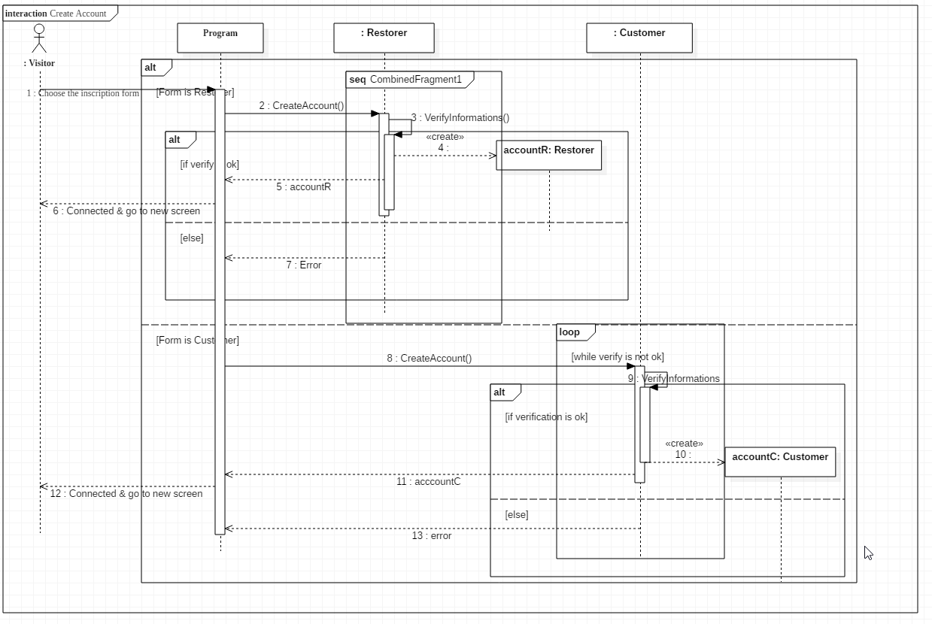

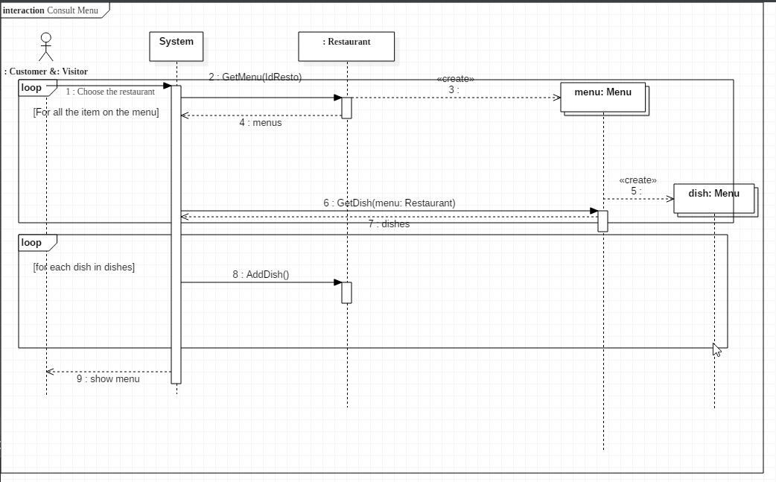

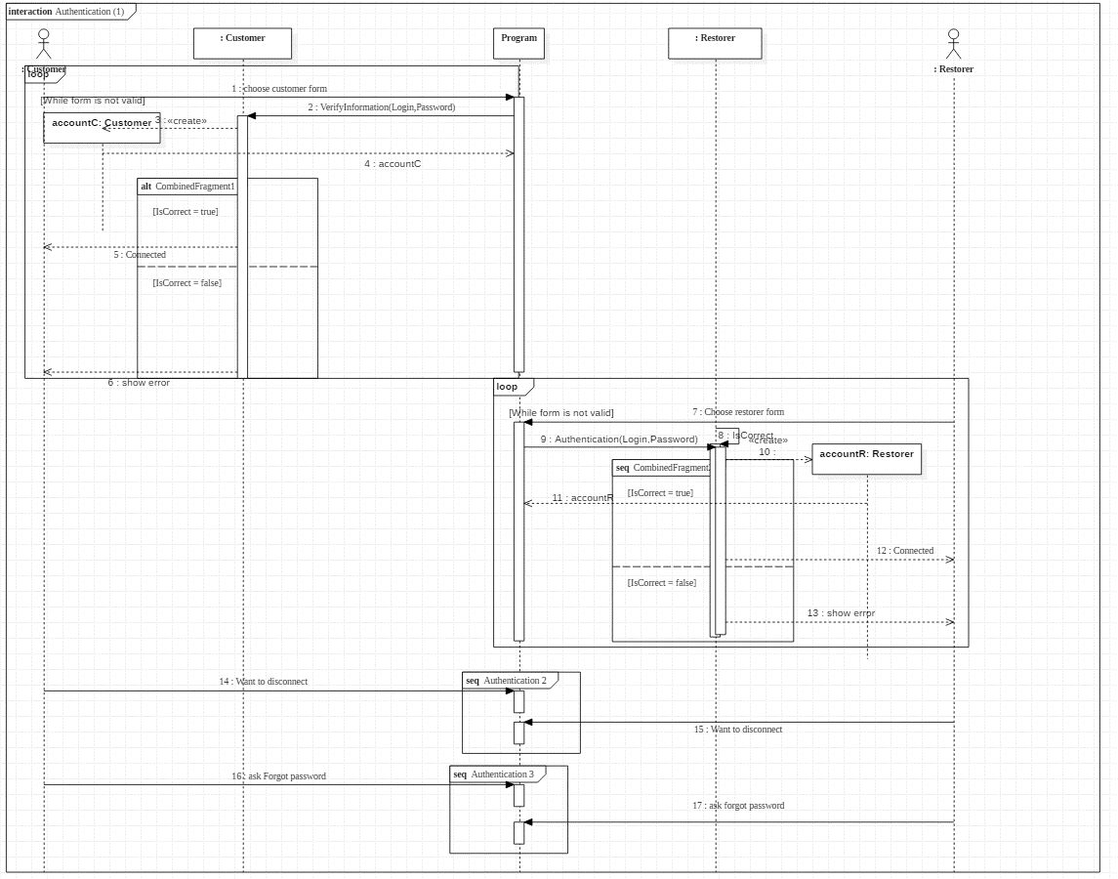

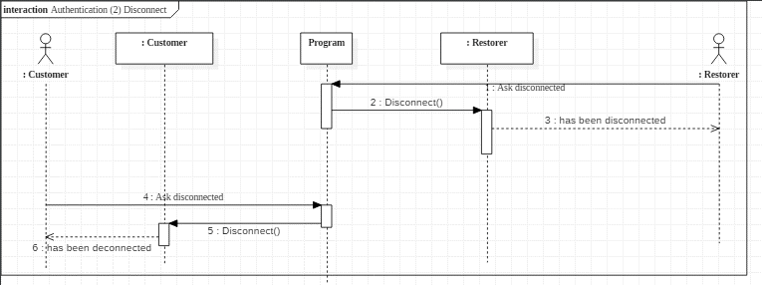

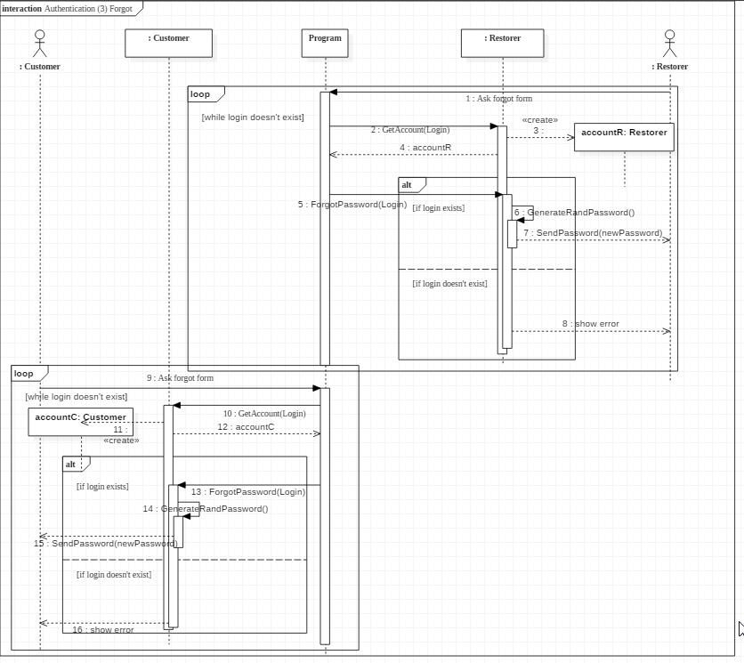

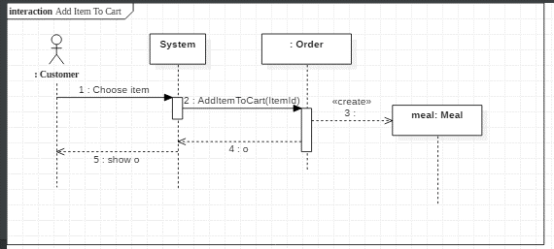

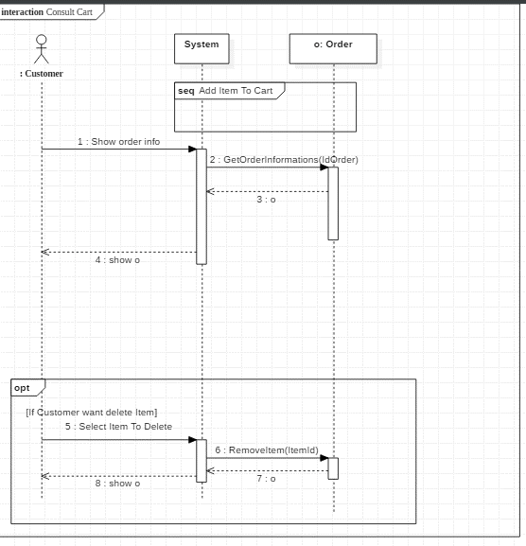

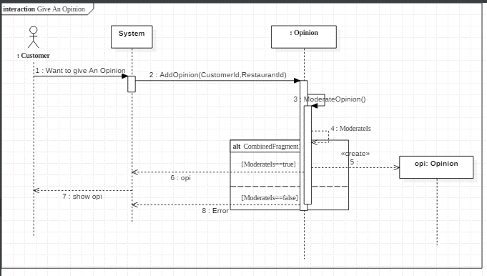

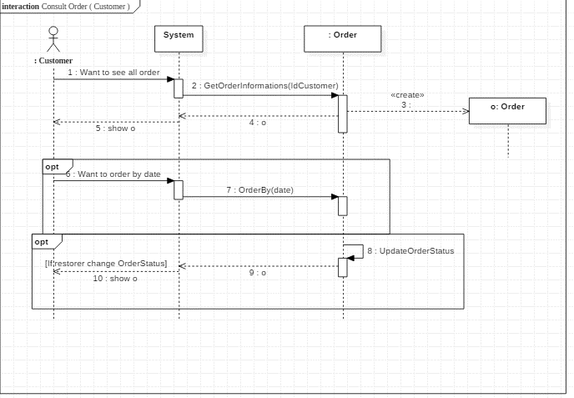

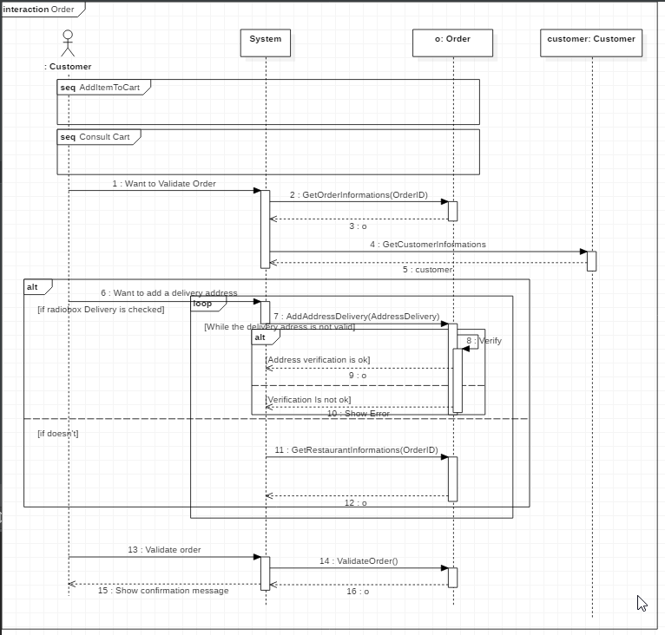

#### Commentaire du professeur

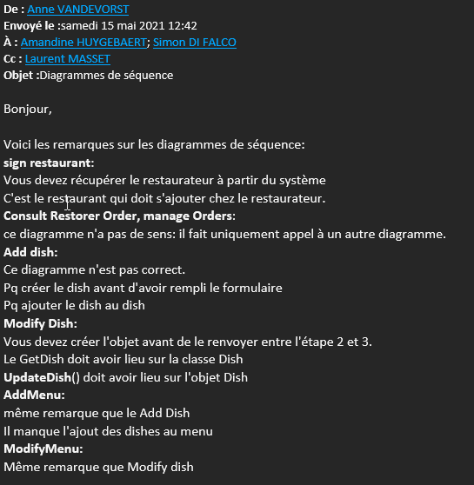

### Jet 3

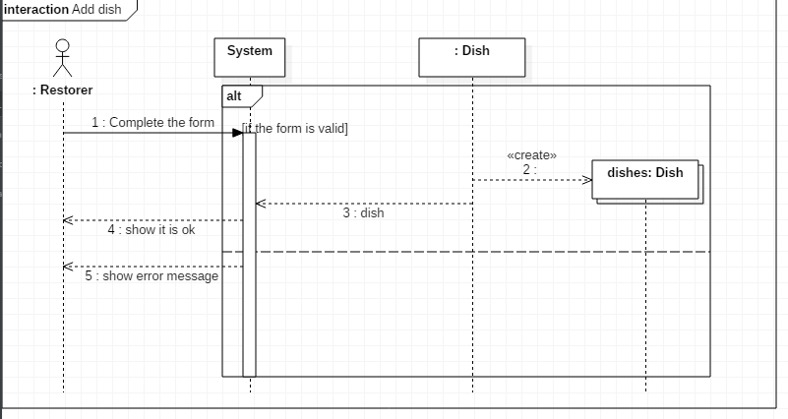

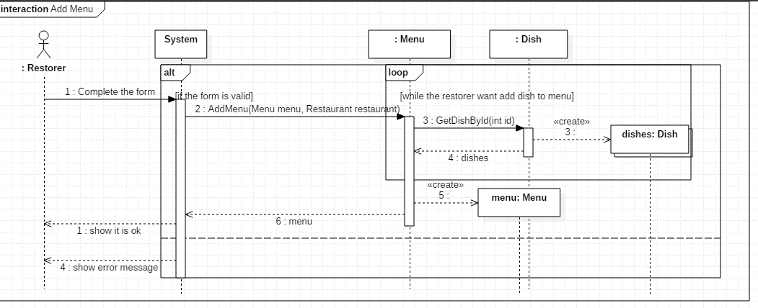

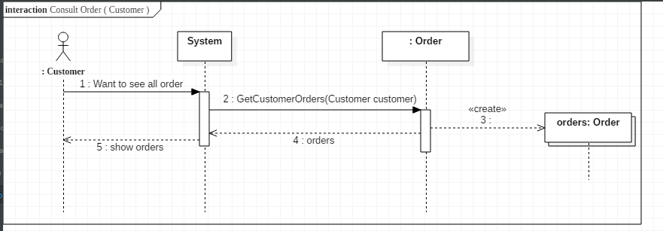

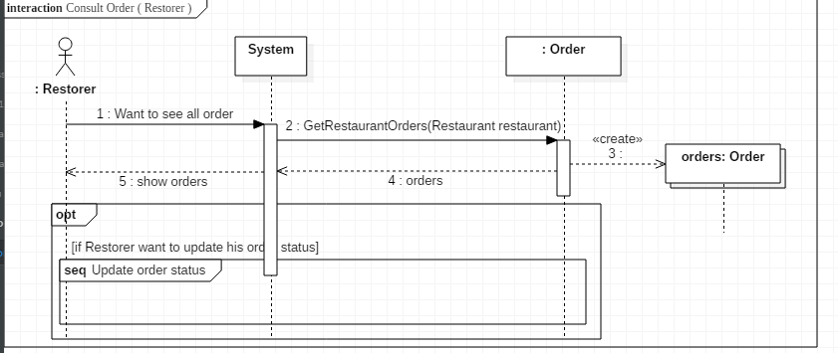

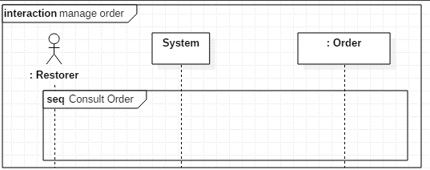

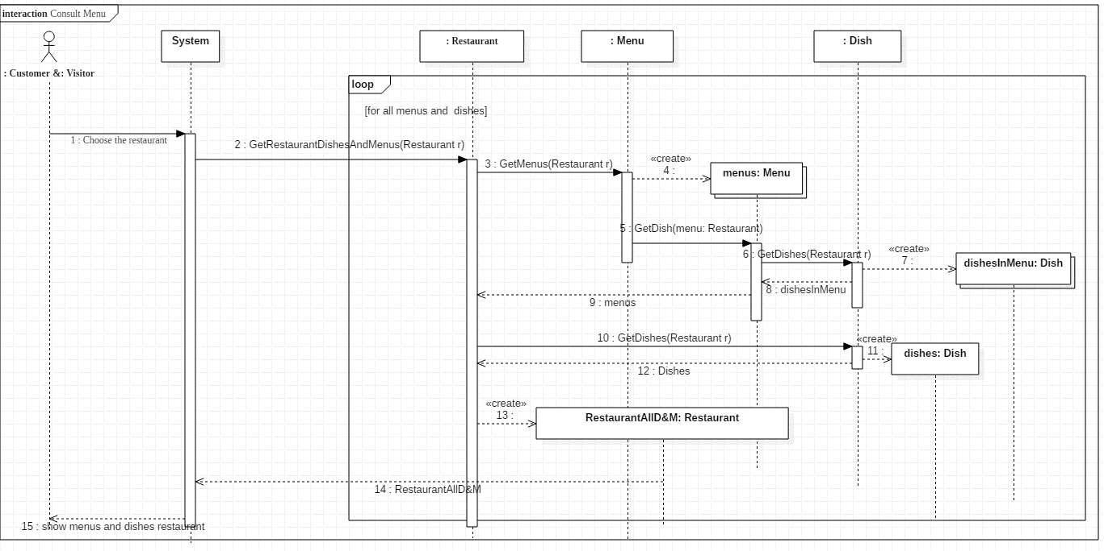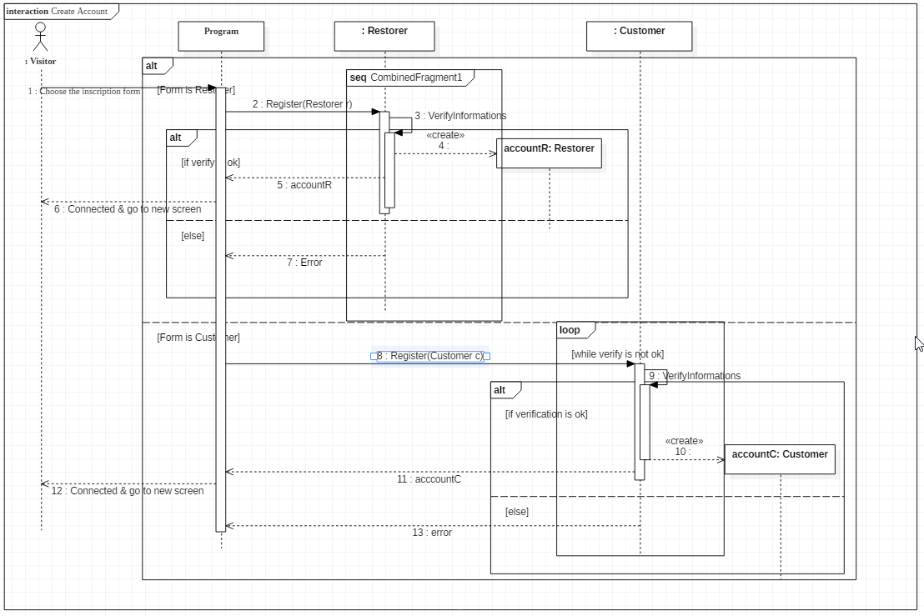

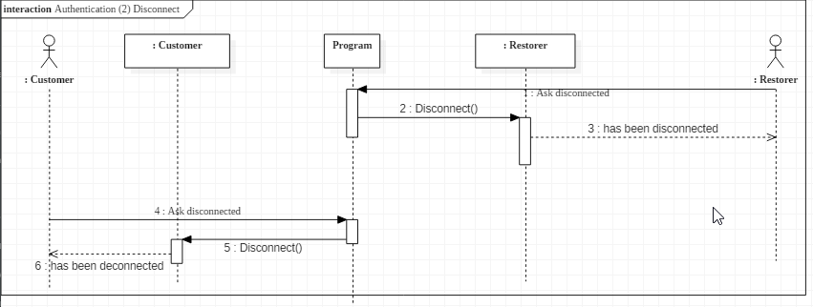

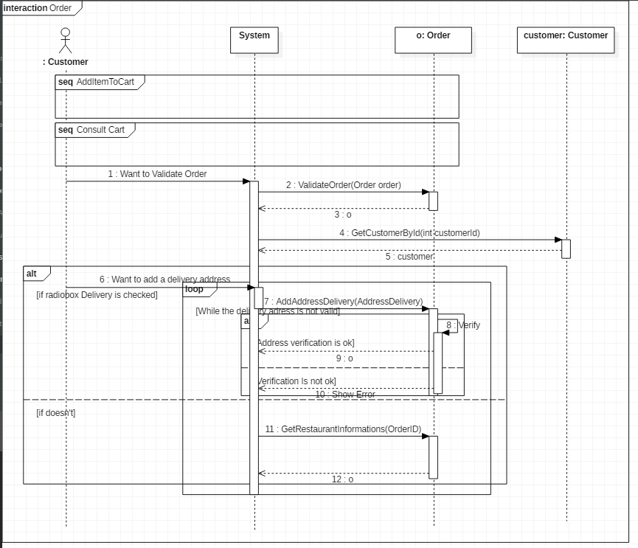

#### Commentaires de l’enseignant

* D’où proviennent les objets passés en paramètres ? Méthodes mal placées, mauvaise communication entre les class.

### Jet final

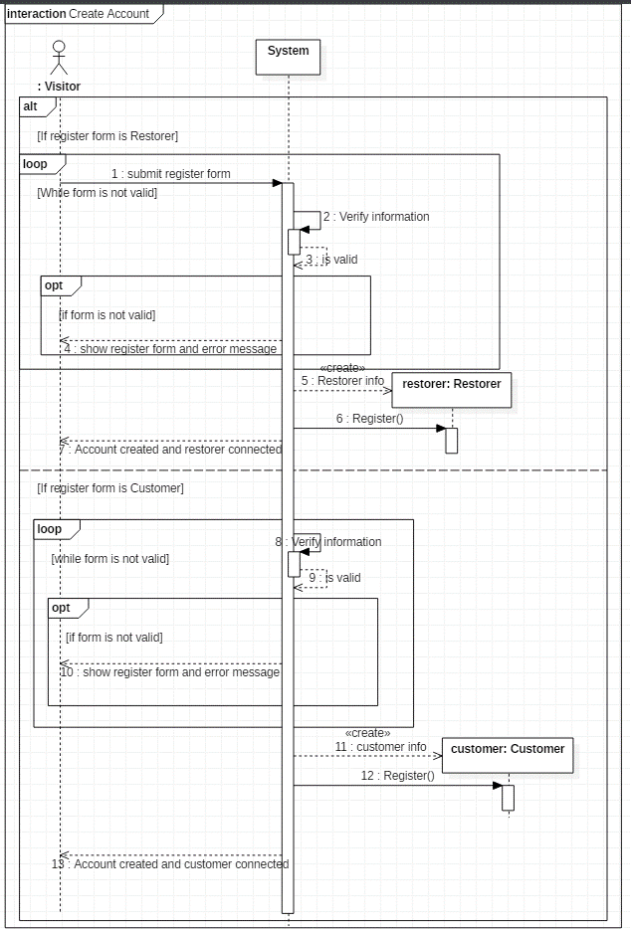

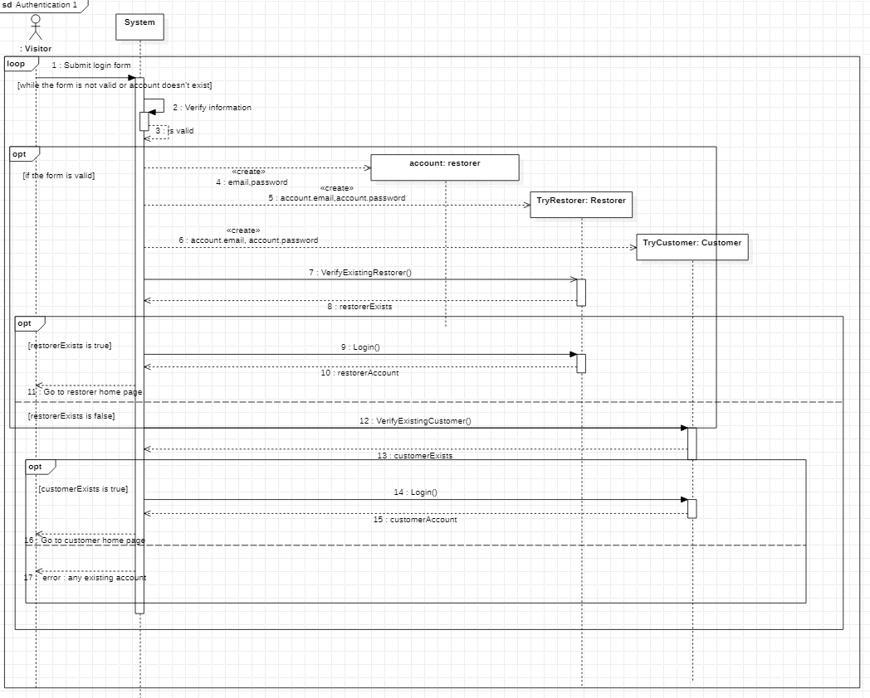

Note : nous avons dû choisir de mettre un account d’un des 2 types en héritant car on ne peut instancier une classe abstract. Donc pour contourner ce problème nous utilisons un objet « Restorer » dans un premier temps, ce qui a peu d’importance car il contient les mêmes propriétés que « Customer » dans ce dont nous avons besoin. Ensuite nous créons donc deux objets, un de type Restorer et un de type customer grâce à l’email et le password récupérés via l’objet de type Restorer qui a servit pour la connexion.

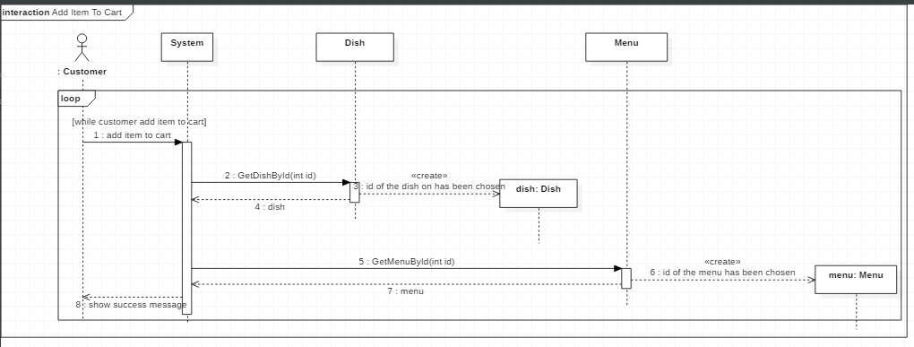

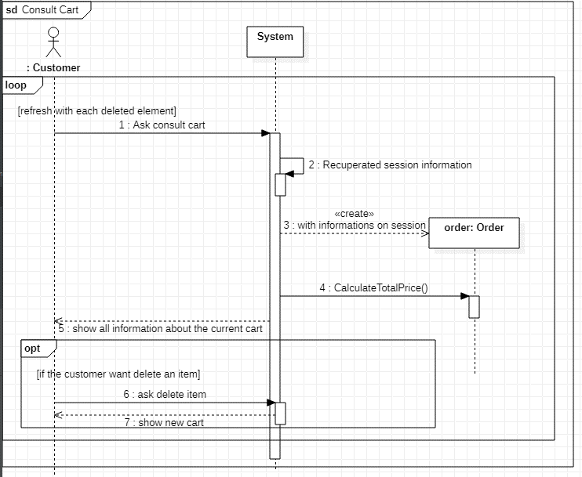

Note : nous avions pensé à gérer le cart via la session donc chaque chose ajoutée dans le cart aura son id stockée en session.

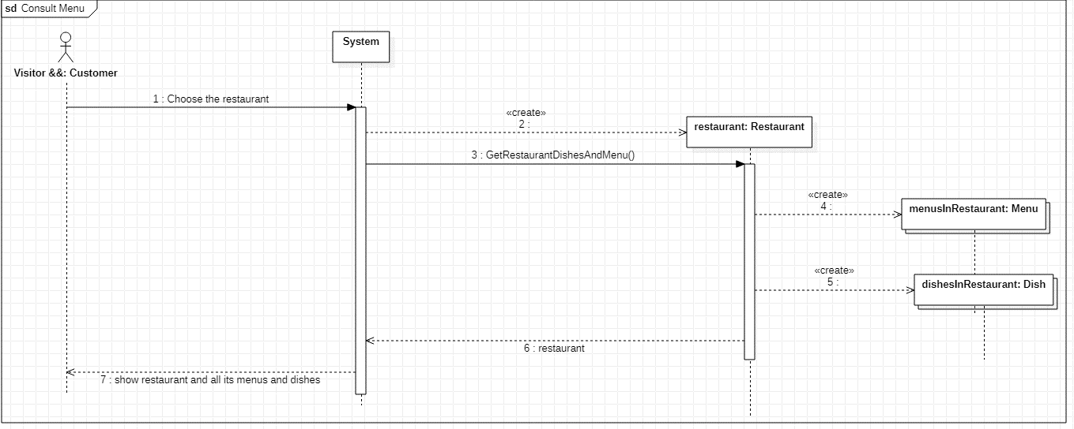

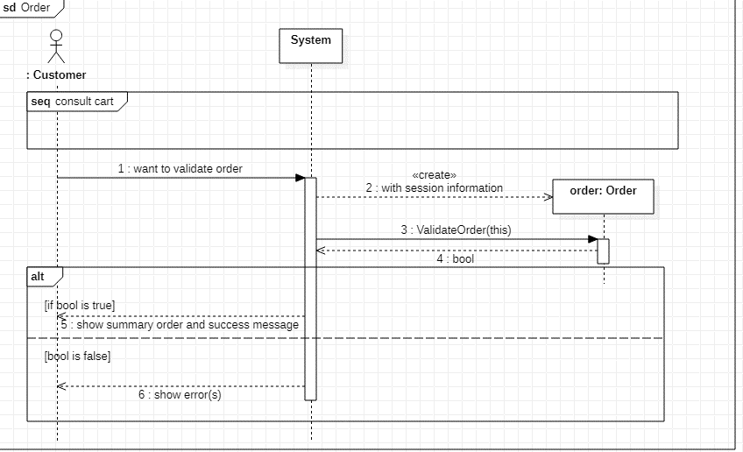

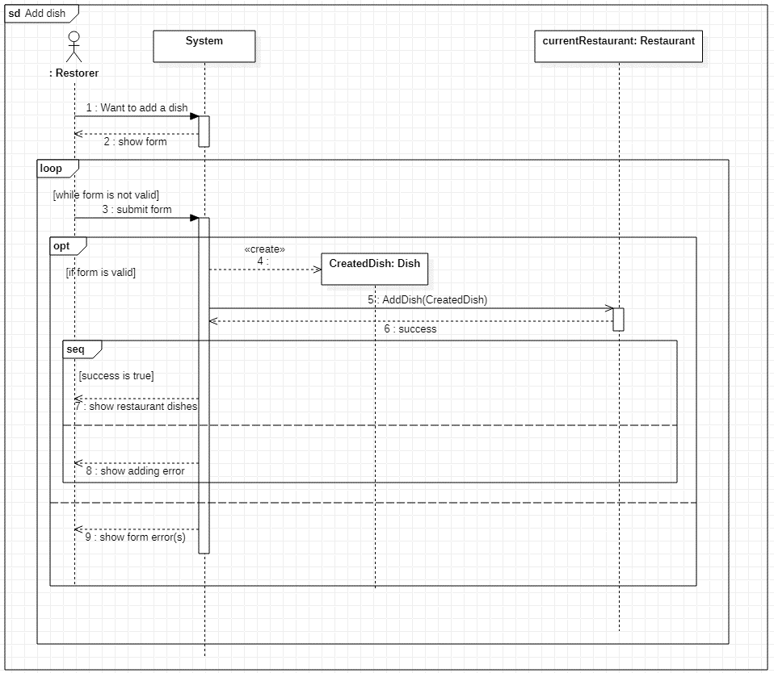

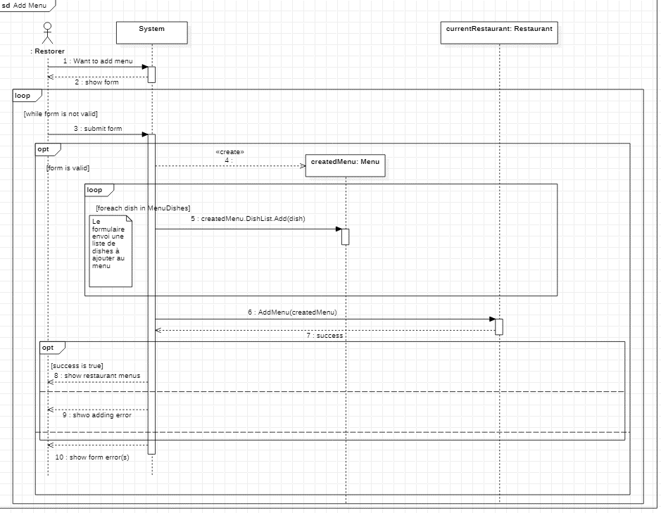

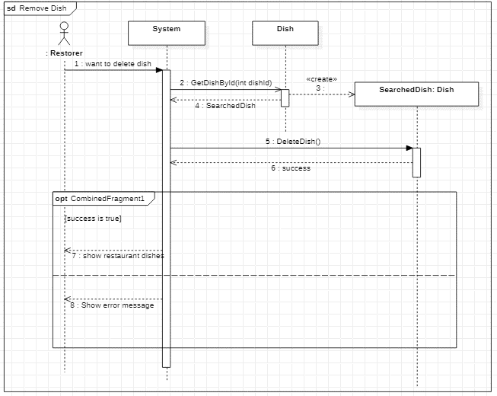

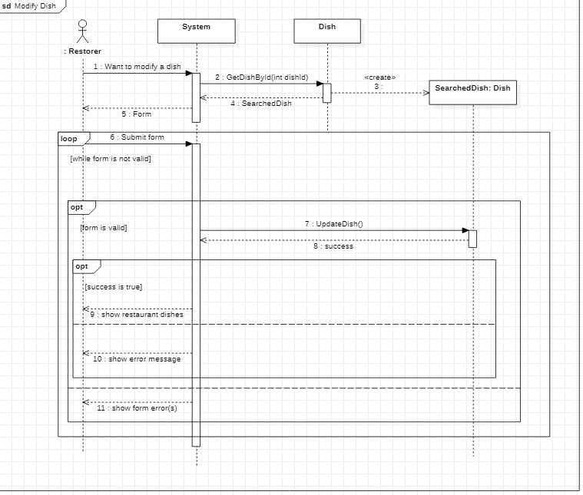

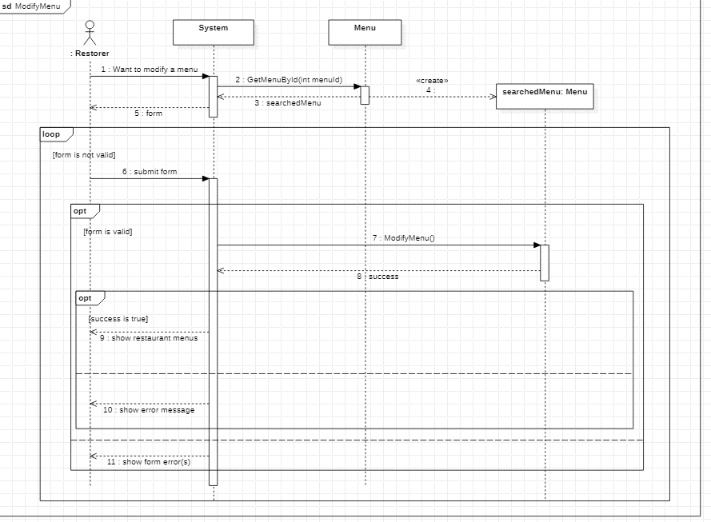

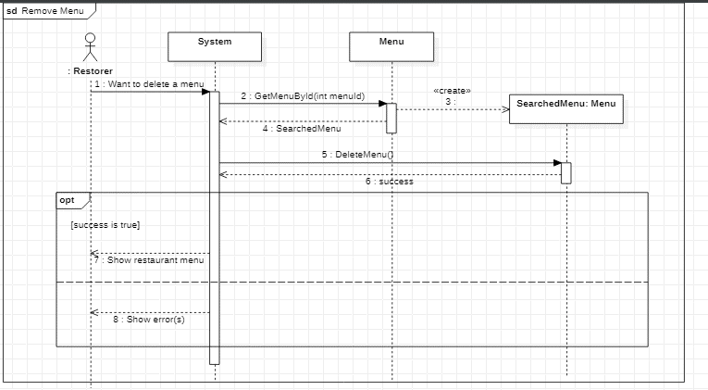

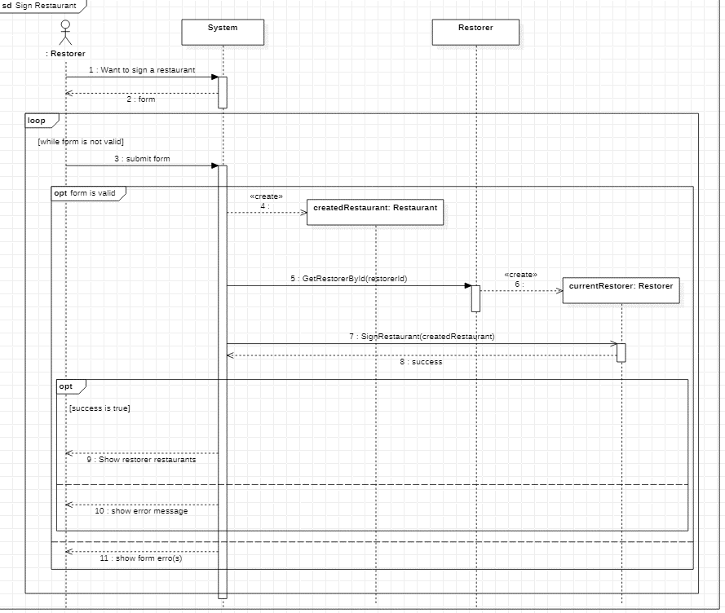

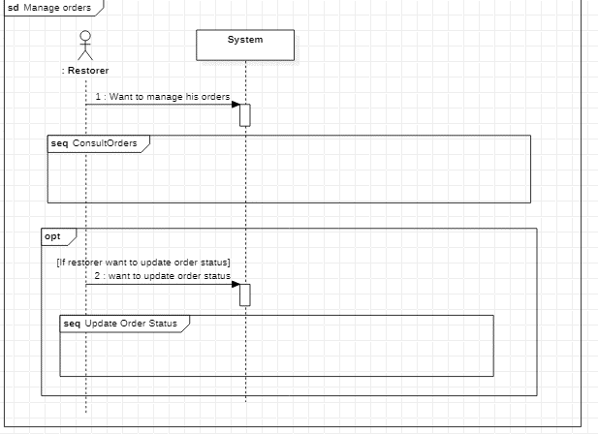

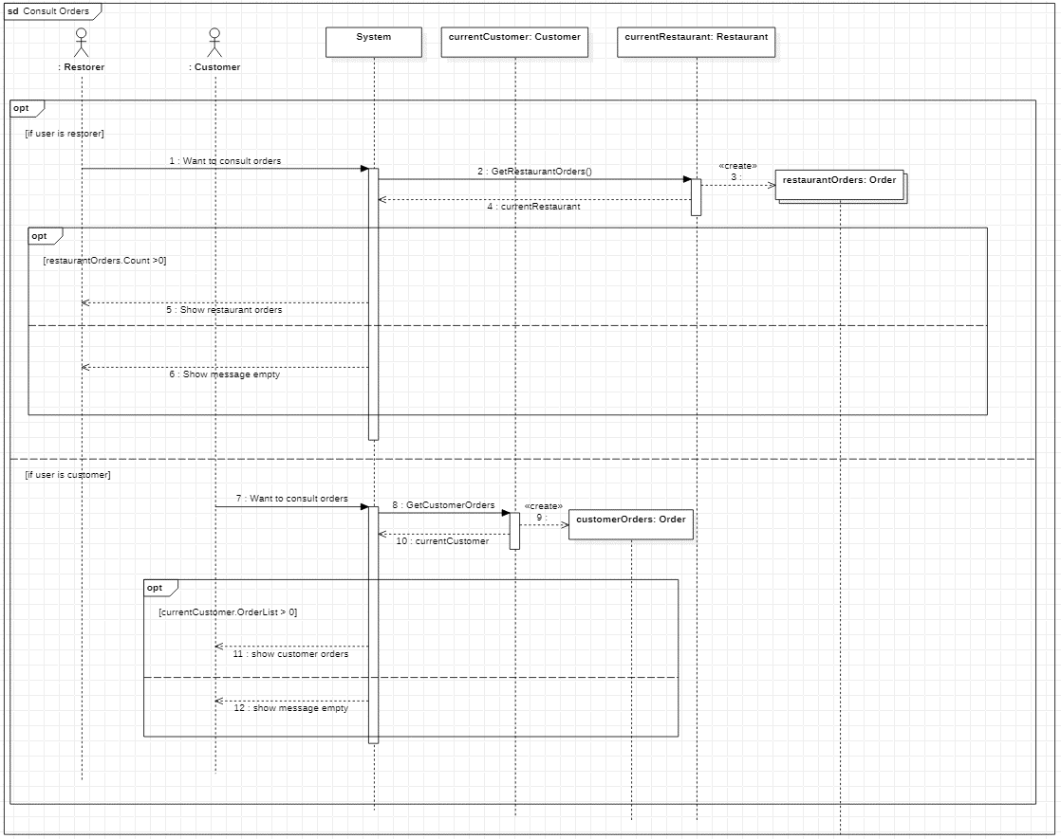

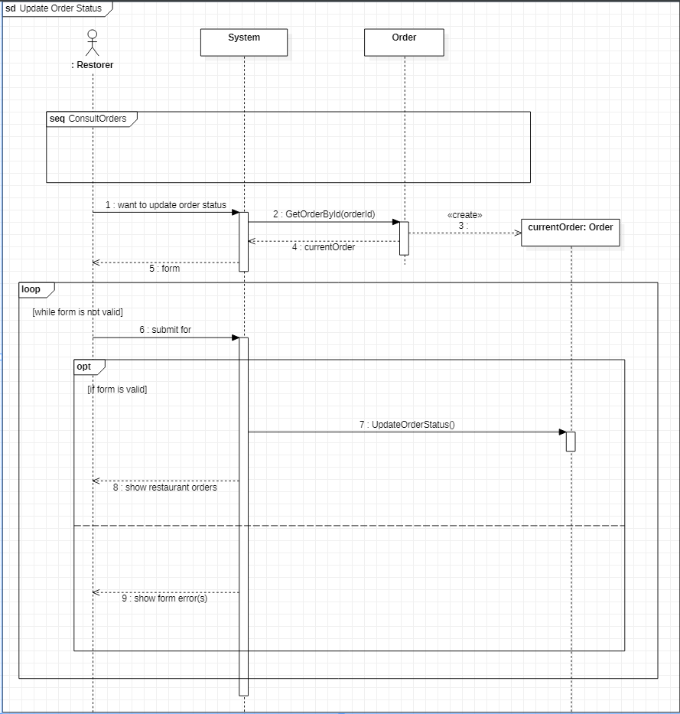

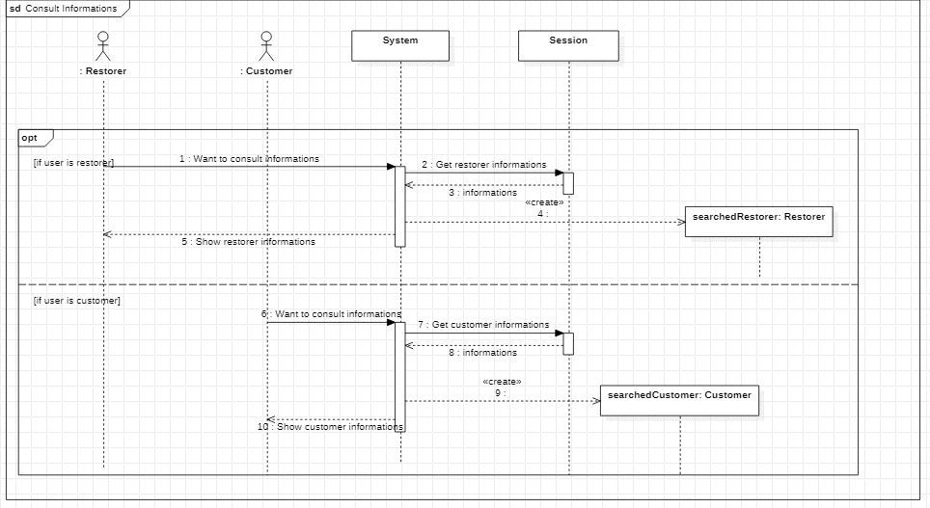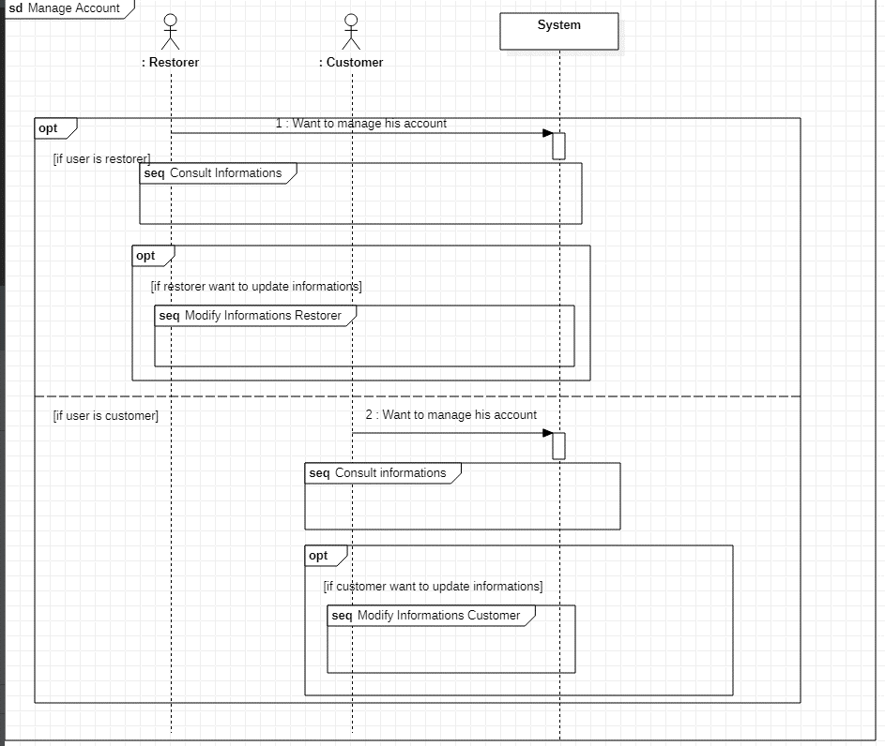

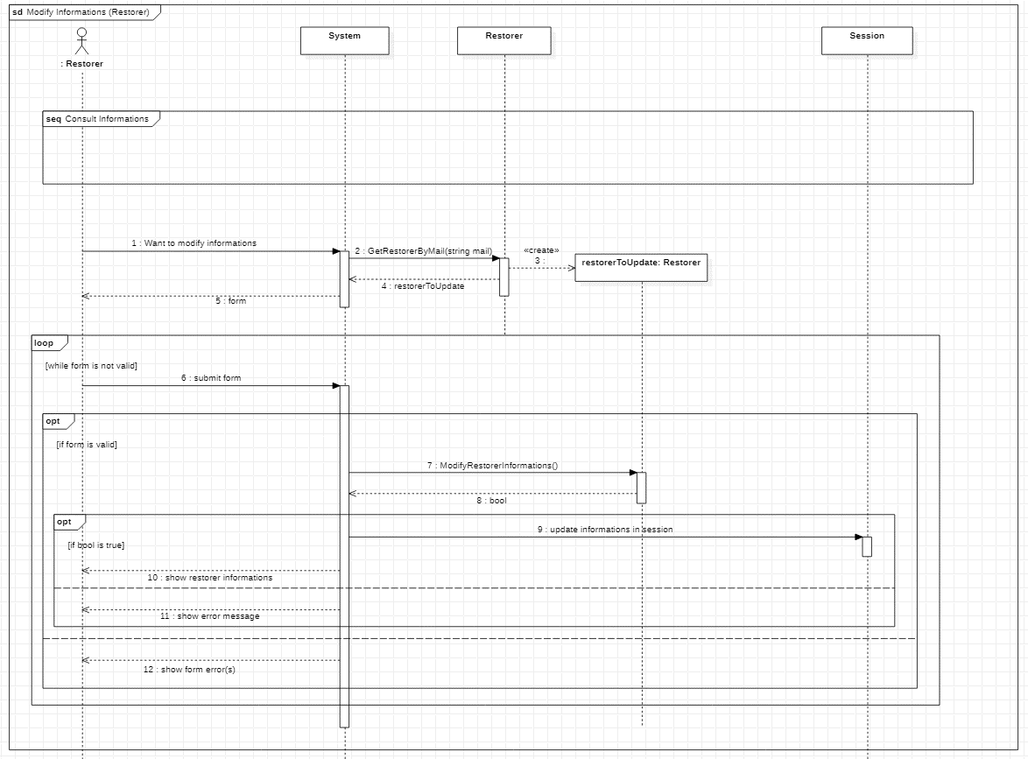

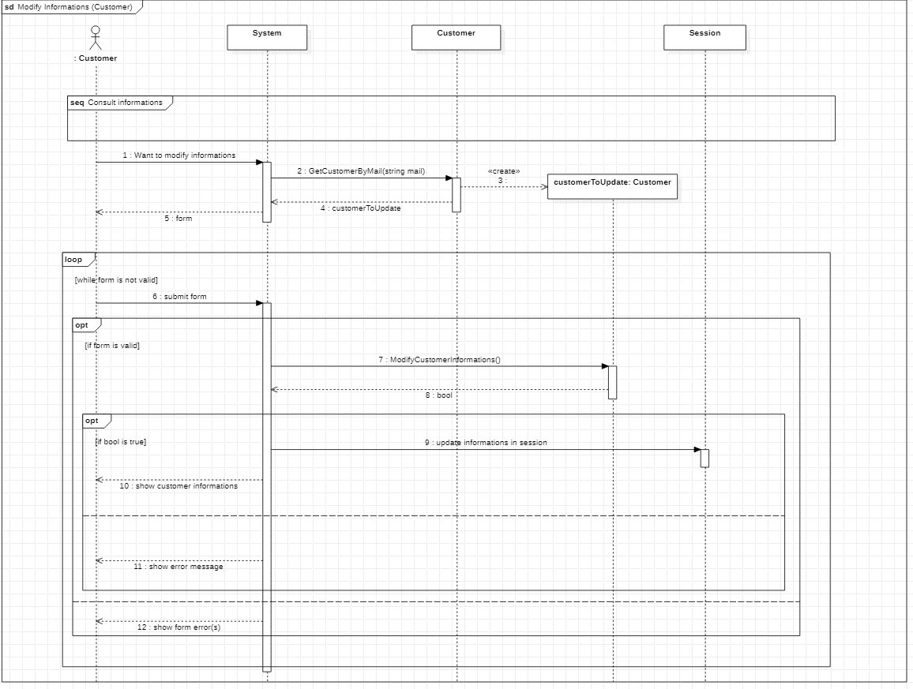

### Version août

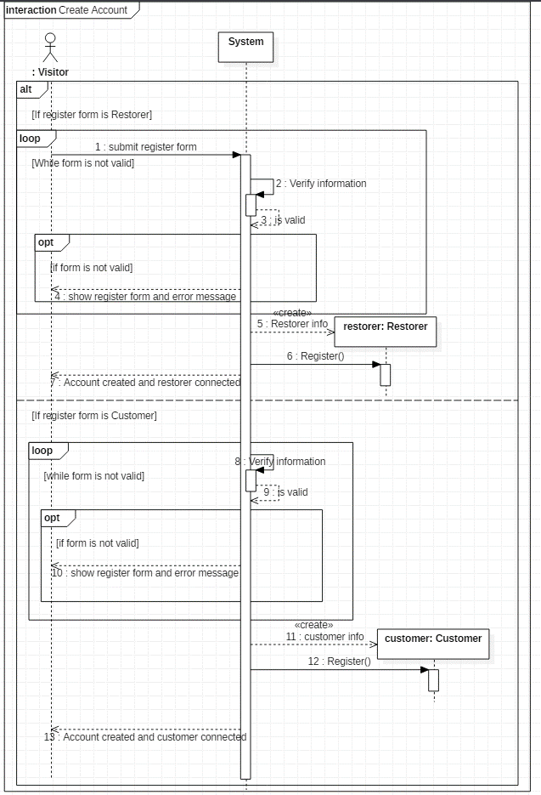

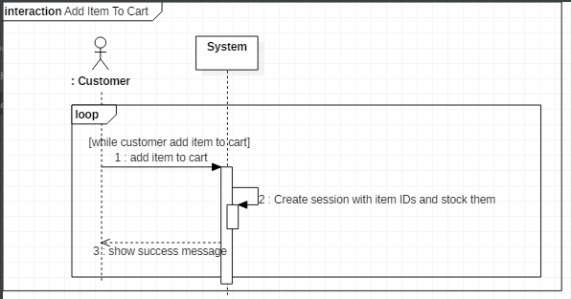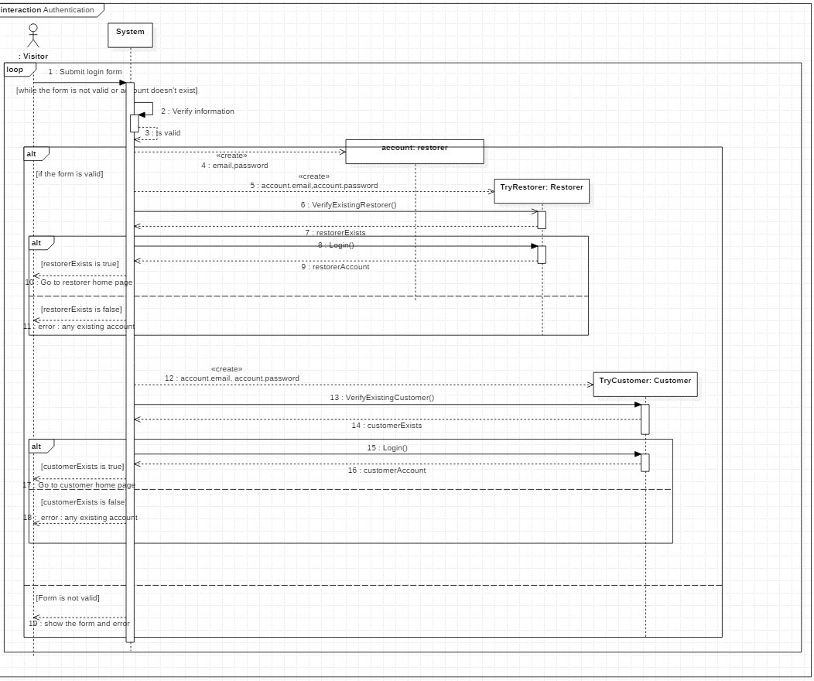

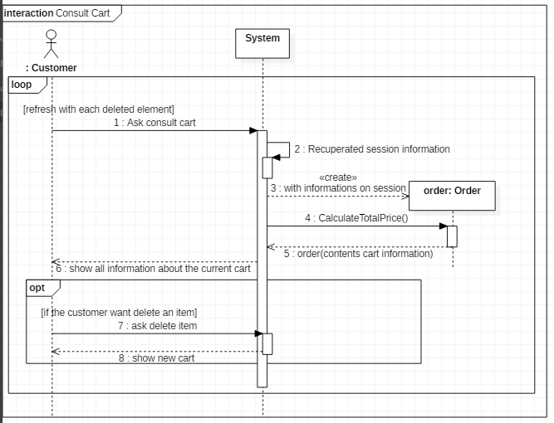

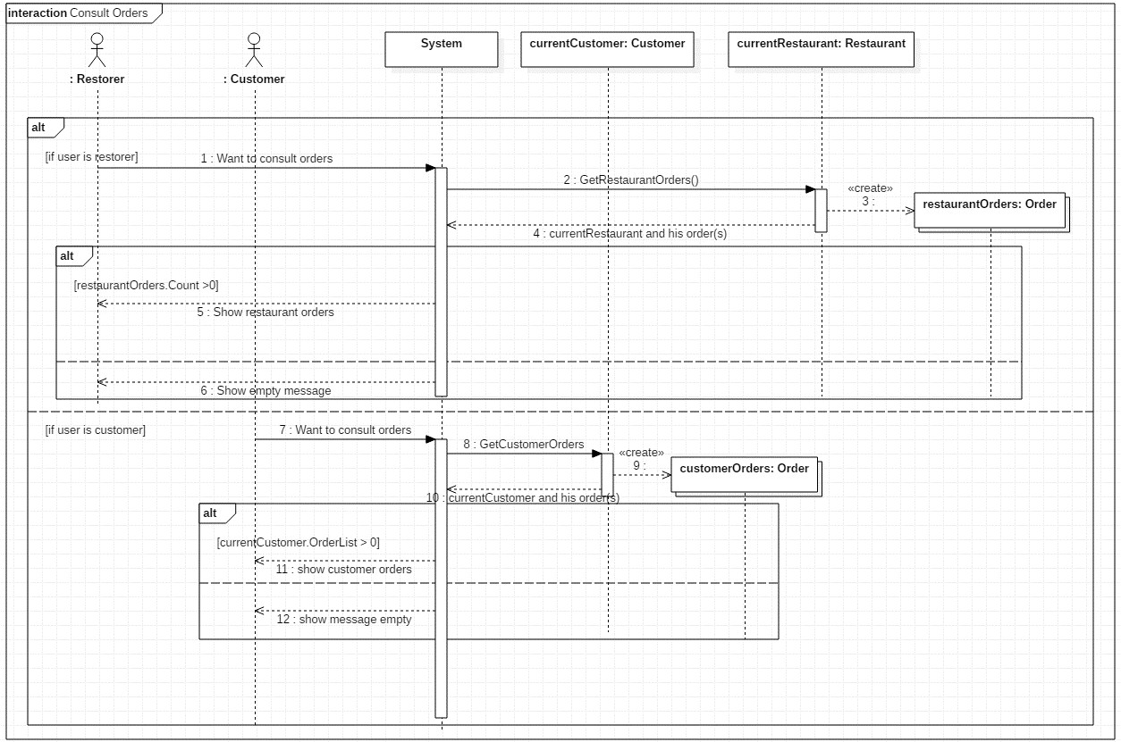

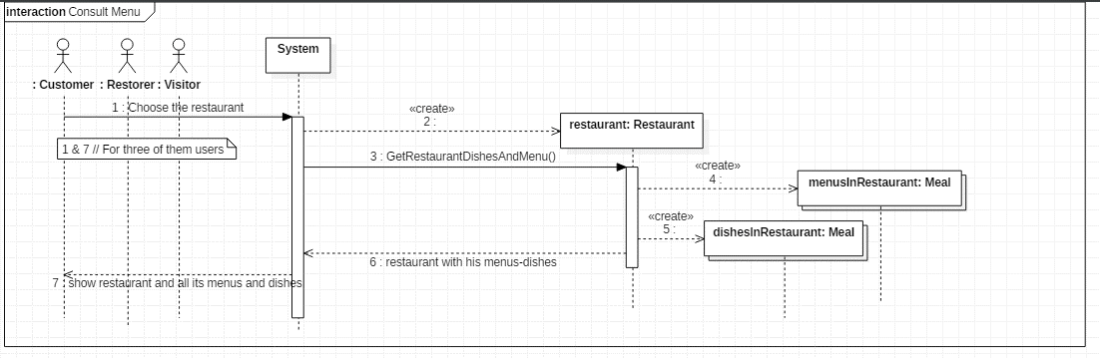

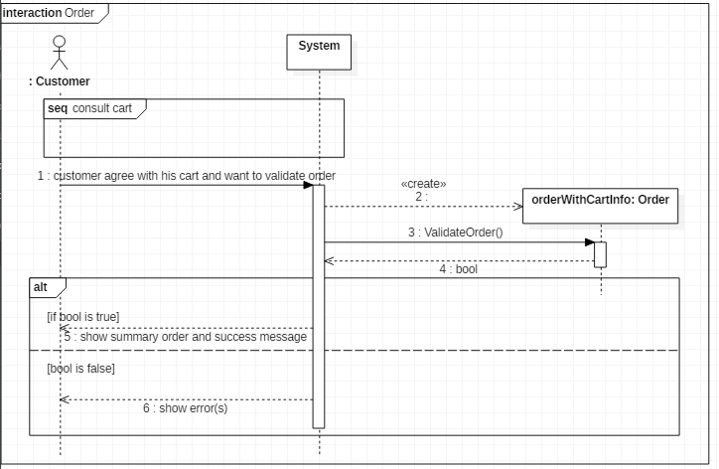

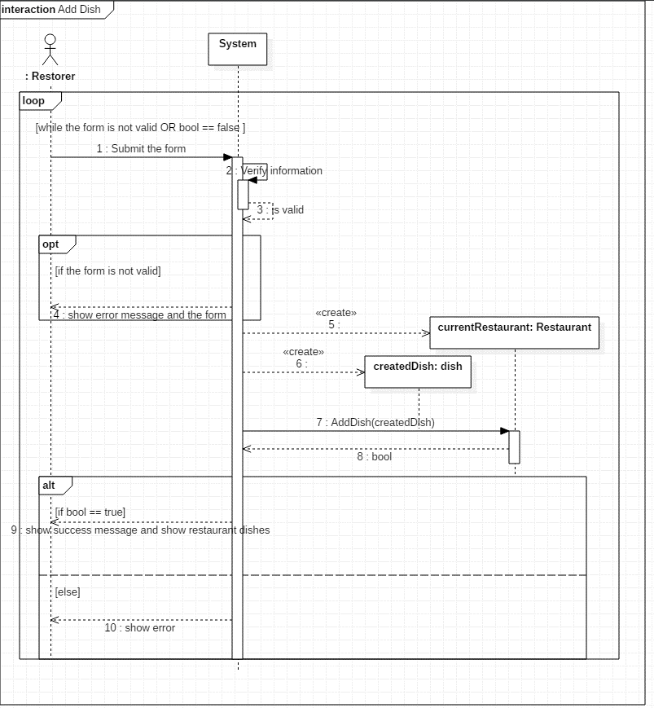

C’est LE RESTAURANT QUI DOIT AJOUTER UN DISH !!!! Pareil delete/modify

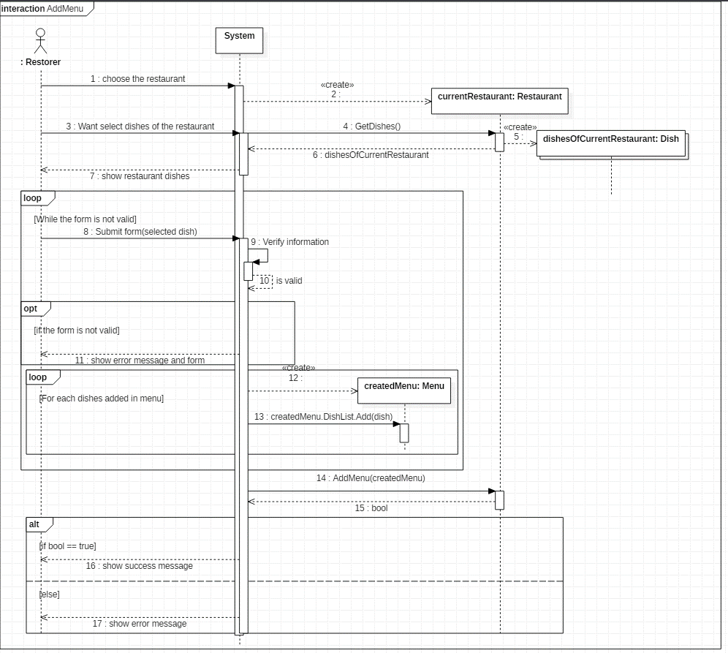

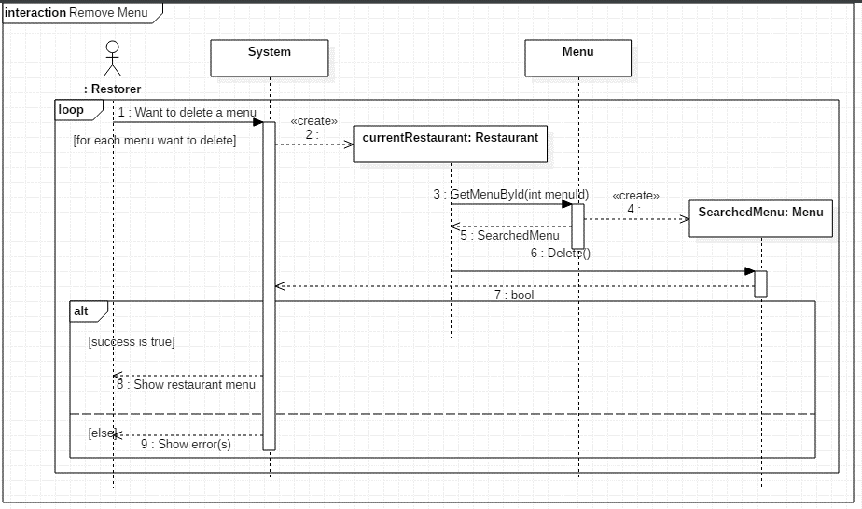

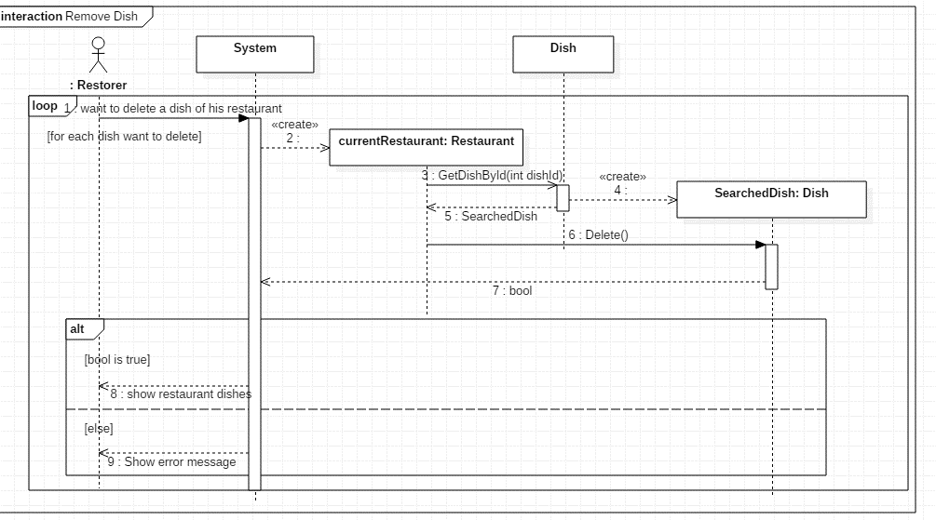

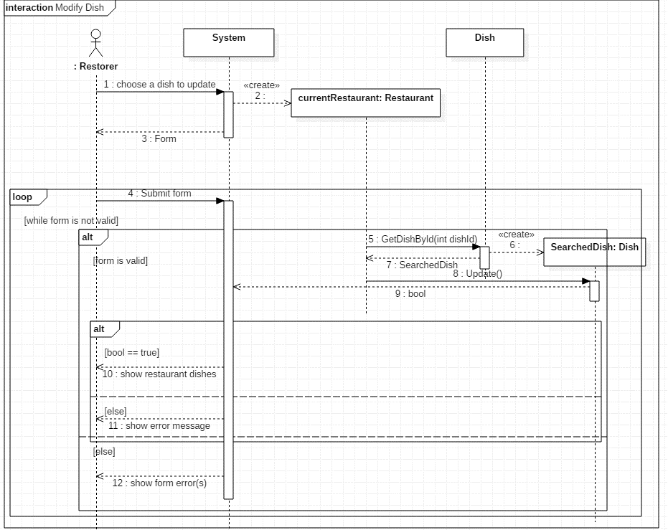

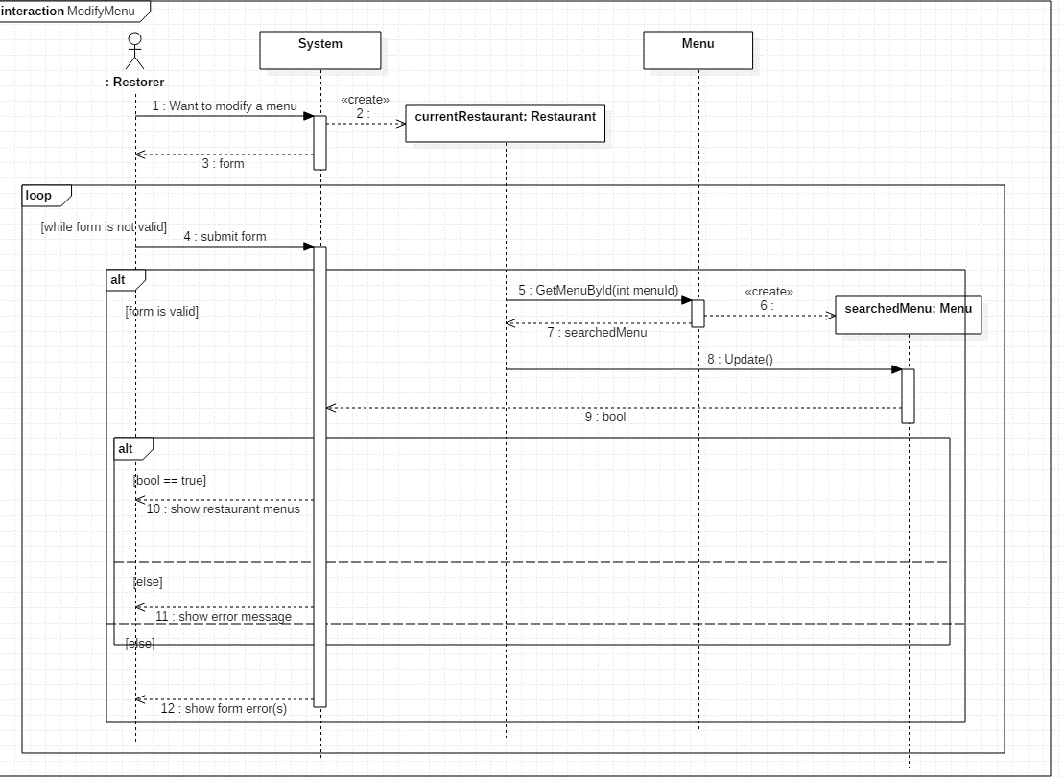

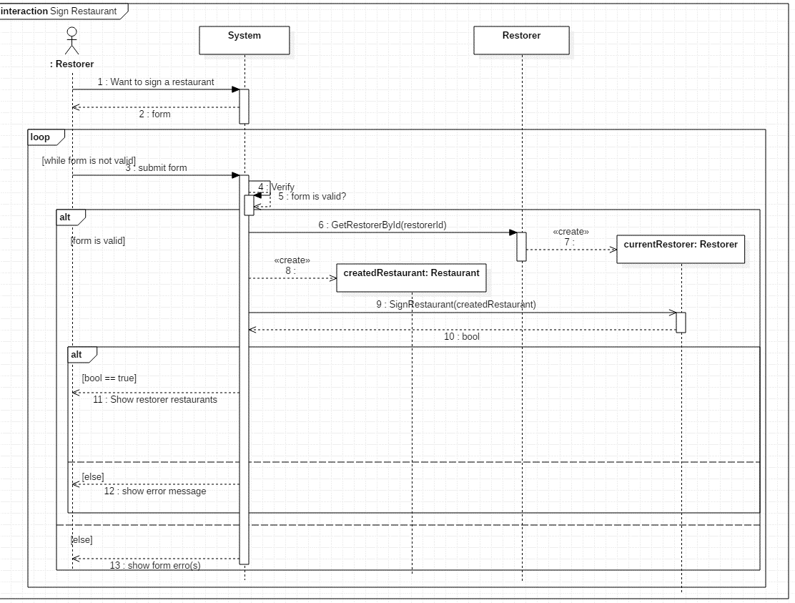

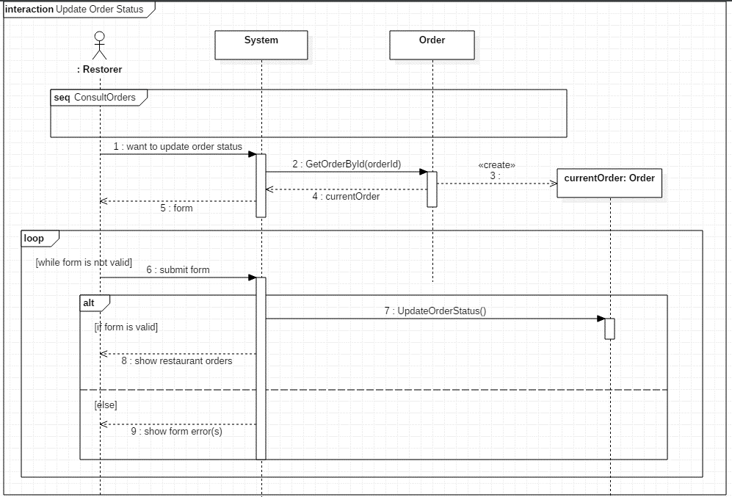

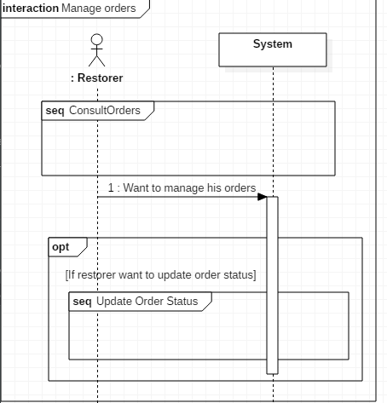

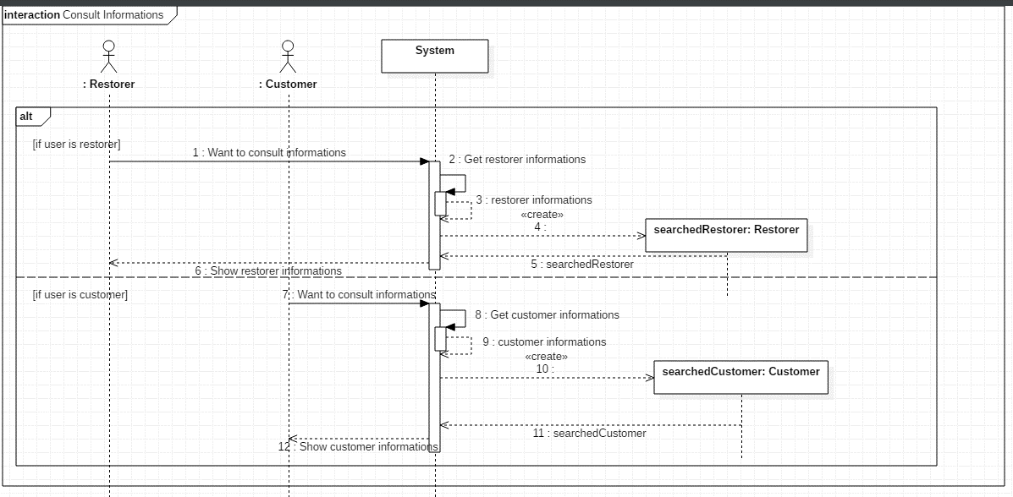

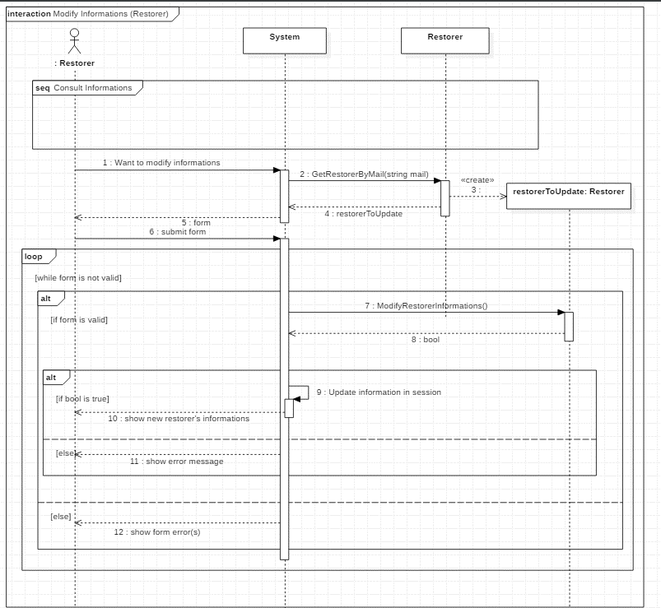

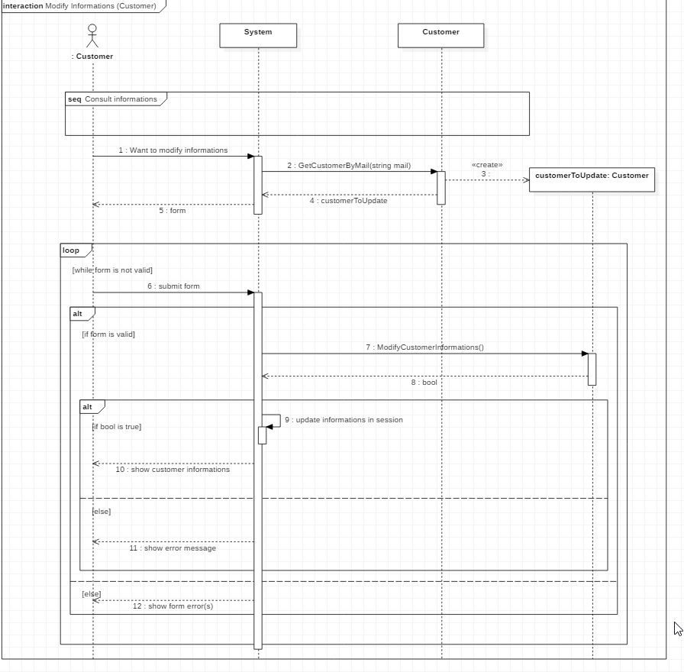

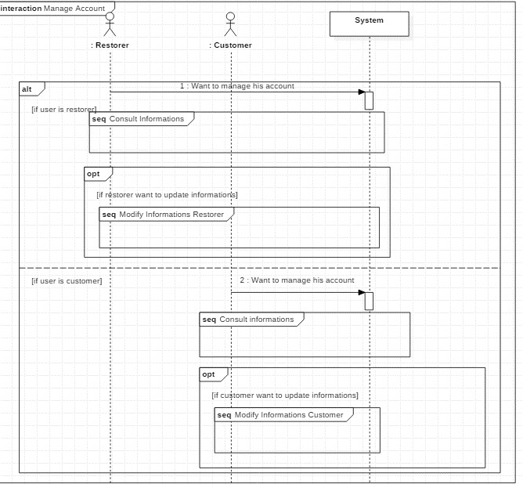

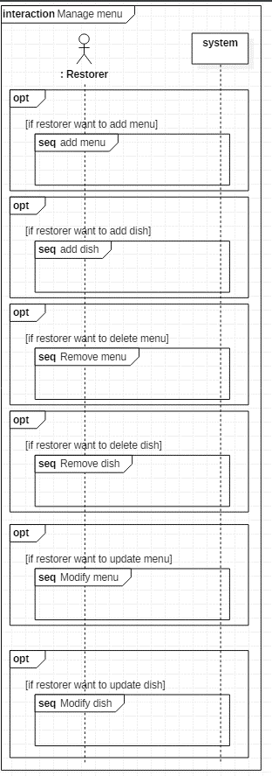

# Conclusion

|  |
| --- |
| L’élaboration de ce projet nous a permis de mettre en pratique les concepts théoriques vus en classe et à être confrontés à des problèmes inhérents au travaux de groupe. Mais aussi à apprendre à tenter de répondre à la demande d’un client dans les délais attendus. Nous avons dû faire un focus sur les fonctionnalités principales dans un premier temps et si le temps nous l’a permis nous avons terminé les moins importantes.  Les notions d’analyse ont été difficilement acquises et ce projet a donc permis une meilleure compréhension de tous les principes d’analyse. |